**EXPOSURE VISIT REPORT**

INDUSTRYNAME: VISWA MARUTHI TYRES AND TUBES, Dharmapuri

DATEOFVISIT: 13.03.2025 (10 A.M to 1 P.M)

ORGANIZER: BIS CLUB, COIMBATORE.

COORDINATOR :MR.S.NIRMAL KUMAR.

**Introduction:**

On 13.03.2025, a group of students from Government College Of Engineering, Dharmapuri, pursuing III year B.E. in Electrical and Electronics Engineering visited Viswa Maruthi Tyres and Tubes. The primary objective of this industrial visit was to gain practical insights into the tyre manufacturing process and understand the application of engineering concepts in a real-world setting.

**Overview of the Industry:**

Viswa Maruthi Tyres and Tubes is a renowned manufacturer known for producing high-quality tyres and tubes for various vehicles. The company is dedicated to producing durable and reliable products by incorporating cutting-edge technology, a systematic manufacturing process, and highly skilled labour to ensure each product meets the highest quality standards.

**Manufacturing Process:**

The students were given a comprehensive overview of the various stages involved in the tyre manufacturing process. The key stages include:

**1. Raw Material Selection:**

The raw materials used in the tyre manufacturing process include natural and synthetic rubber, carbon black, butyl rubber, zinc oxide, sulphur, and other chemicals.

Thesematerials are carefully selected to ensure optimal performance, durability, and safety in the final product.

**2. Kneading (Kneader Machine):**

The selected raw materials are fed into a kneader machine where they are mixed andprocessed to form a homogeneousrubber compound. This stage involves combining the rubber with other ingredients like zinc oxide, sulphur, and accelerators to achieve the required characteristics such as strength, elasticity, and heat resistance.

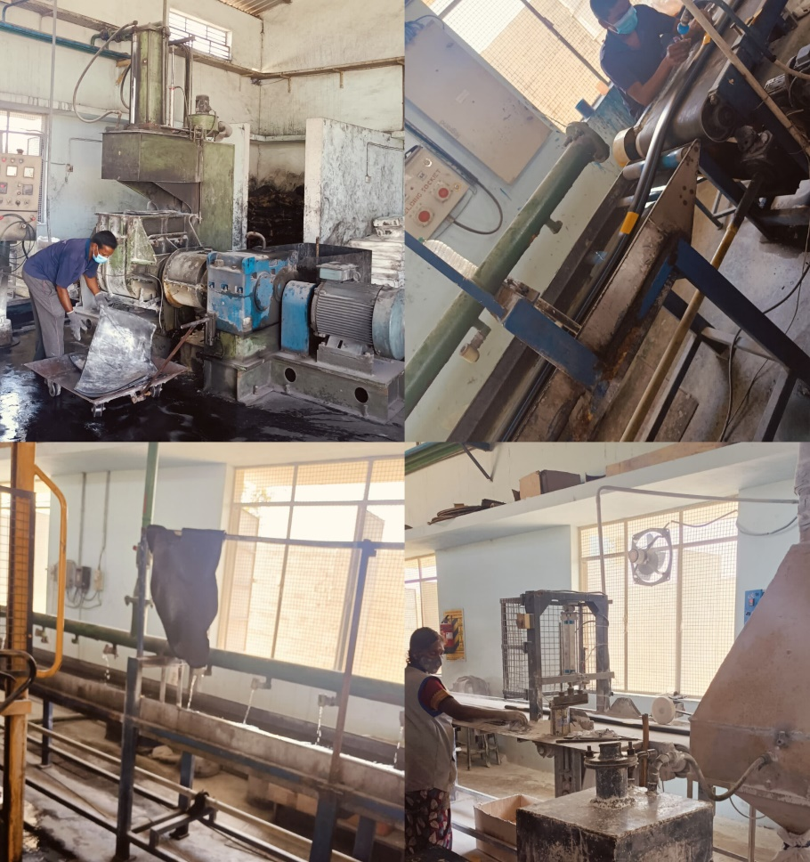

**3. Mixing:**

The rubber compound created in the kneader machine is further mixed to ensure consistency in texture and properties, preparing it for the next stage of tyre manufacturing.

**4. Tyre Building (Executor Machine):**

In the tyre-building stage, the compound is carefully layered with fabric and steel cords in an executor machine. This process forms the structural framework of the tyre, ensuring that it can bear weight and endure the stresses of use.

**5. Cooling Process:**

Once the structure is formed, the tyre undergoes a cooling process. The cooling helps solidify the rubber compound, giving it the necessary rigidity and strength before it is sent to the next phase.

**6. Powdering Process:**

After cooling, the tyres are powdered to avoid sticking during the subsequent steps. The powdering process is crucial in ensuring that the tyres can be handled easily without any risk of deformation or damage.

**7. Valve Fitting:**

In this step, a valve is inserted into the tyre. This ensures that the tyre can be inflated and deflated as needed. The valve fitting is an essential part of the tyre manufacturing process as it contributes to the overall functionality of the tyre.

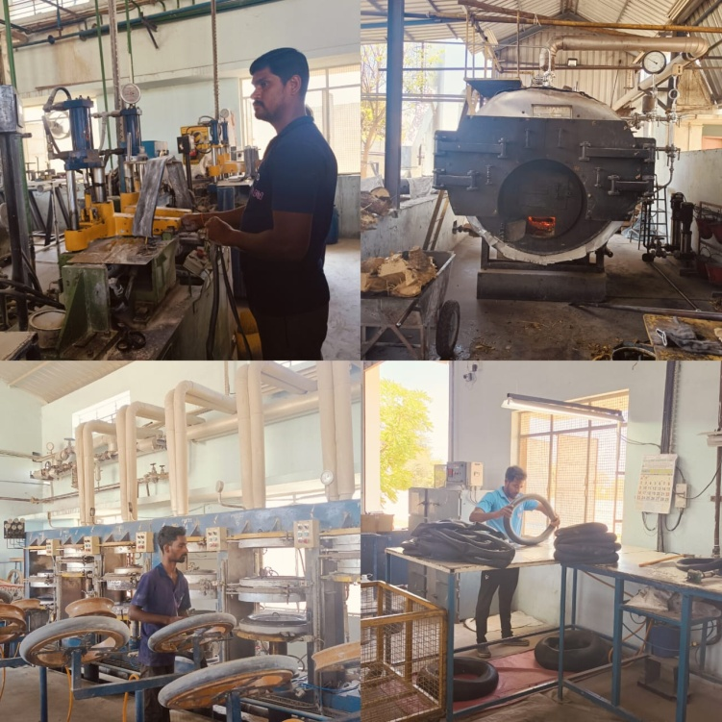

**8. Moulding:**

The tyre is then placed into a mould where it is heated under high pressure to take its final shape. This process is known as vulcanization, where the rubber undergoes a chemical change due to the heat, making it stronger, more durable, and resistant to wear and tear.

**9. Curing and Vulcanization:**

The final curing stage solidifies the tyre by heating it in a mould. The heat causes the sulphur to bond with the rubber molecules, improving the tyre’s durability and performance, such as wear resistance, heat tolerance, and elasticity.

**10. Boiler and Steam Process:**

The factory also utilizes a boiler system, which generates steam for the vulcanization process. The high-pressure steam plays a crucial role in maintaining optimal temperatures during the curing phase, ensuring that the tyres acquire the correct chemical properties and consistency. The use of steam in the process helps enhance the efficiency and quality of the final product.

**11. Quality Checking Process:**

After the tyres have undergone all the manufacturing stages, they are subjected to rigorous quality checks. This process involves visual inspection, dimensional checks, and advanced testing methods to assess factors such as strength, balance, durability, and wear resistance. Automated machines and manual inspection ensure that only tyres meeting the highest safety and quality standards are approved for distribution.

**Key Learnings:**

* The role of automation and specialized machinery in streamlining the manufacturing process.
* The significance of quality control at each stage to ensure safety and performance.
* Insight into industrial safety protocols and the importance of maintaining high standards for worker safety.
* The application of chemical engineering concepts, such as vulcanization, in improving product durability.
* Hands-on exposure to real-world industrial processes and technology.
* Understanding the crucial role of the boiler and steam systems in ensuring efficient vulcanization.

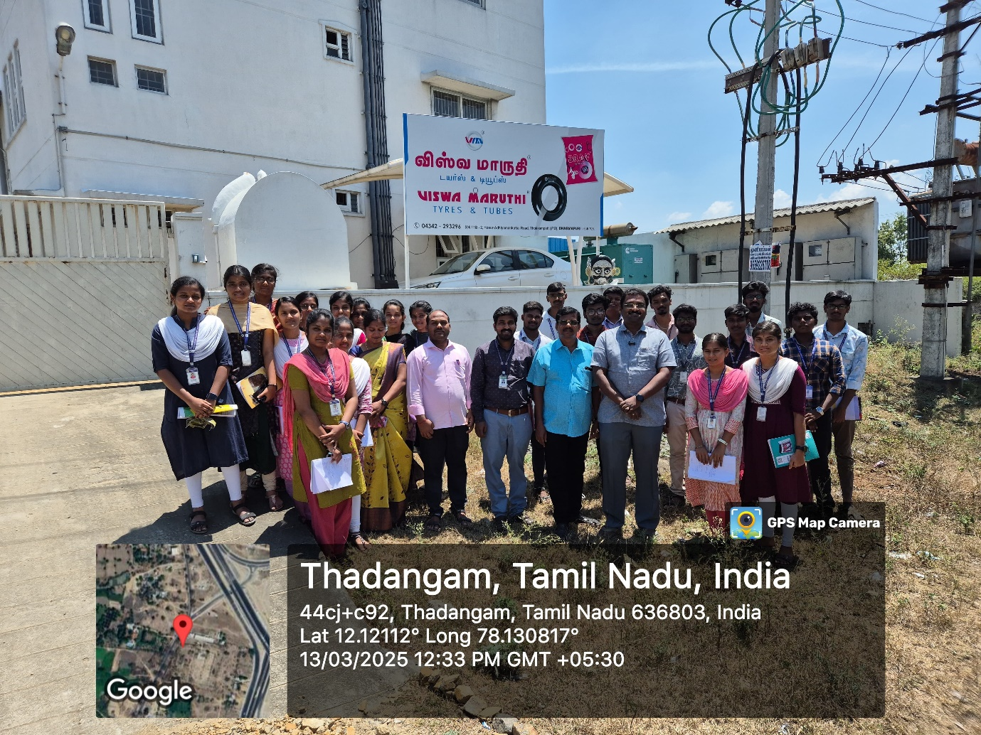

**Conclusion:**

The visit to Viswa Maruthi Tyres and Tubes was an enriching experience that provided valuable insights into the intricate processes involved in tyre manufacturing. The students gained a deeper understanding of the practical application of engineering principles in an industrial setting. The visit significantly enhanced their theoretical knowledge and broadened their perspective on manufacturing technology.

.