GOVERNMENT COLLEGE OF ENGINEERING, DHARMAPURI – 636 704
DEPARTMENT OF ELECTRICAL AND ELECTRONICS ENGINEERING
REPORT ON WORKSHOP CONDUCTED

Title: Workshop on “Future trends in Electric Vehicle Technology”.
Duration of Training: Two days(10.09.2025 & 11.09.2025)
Resource Person: Mr. PRASANTHKUMAR PALANI, Chief Technical Consultant, Haritha Mobility solutions, EVK thottam, Mummoorthi Nagar, Tiruppur – 641602,Contact no: 9786196955.
Convenor: Dr.S.Senthilkumar, HOD/EEE
Co-ordinator Name: Prof. S. Nirmalkumar, Assistant Professor/ EEE
No of Students participated: 58 Amount Spent: Rs. 25,500 (Approx)

Objective:
To provide strong insights on fundamental and advanced knowledge about Electric Vehicles (EVs). The program aimed to bridge the gap between academic learning and real-time industry practices in EV technology.
The workshop focused on understanding EV components such as traction battery, inverter, motor, BMS, charging systems, and safety standards. It also aimed to create awareness about EV industry growth in India, government initiatives like FAME-II, and career opportunities available for Electrical and Electronics Engineering students.
Another important objective of the program was to provide practical exposure through block diagrams, component explanation, traction inverter design, high-voltage safety measures, and live EV driving experience. This helped students to gain hands-on knowledge and improve their technical confidence in the EV domain.

Program Overview:
The workshop was inaugurated with a welcome address by Dr.S.Senthilkumar, HOD/EEE. The introduction of the resource person and necessity of the workshop are addressed by Prof. S. Nirmalkumar, Assistant Professor/ EEE. The two-day workshop on “Future Trends in Electric Vehicle Technology” was conducted on 10.9.2025 and 11.9.2025. The program provided students with basic and advanced knowledge about Electric Vehicles (EVs) and their importance in modern transportation.

The sessions covered EV fundamentals, advantages and disadvantages, EV industry growth, major components such as battery, motor, inverter, and charging systems. High-voltage safety, traction inverter design, and PMSM motors were also explained. The workshop included with interactive discussions and a live EV driving demonstration

Day 1 – Session 1 (Morning Session)
The session started with a detailed introduction to Electric Vehicles, where the resource person given insight of the evolution of transportation from conventional Internal Combustion Engine (ICE) vehicles to modern electric mobility solutions. He emphasized the increasing demand for sustainable transportation due to global warming, depletion of fossil fuels, and increasing air pollution levels.
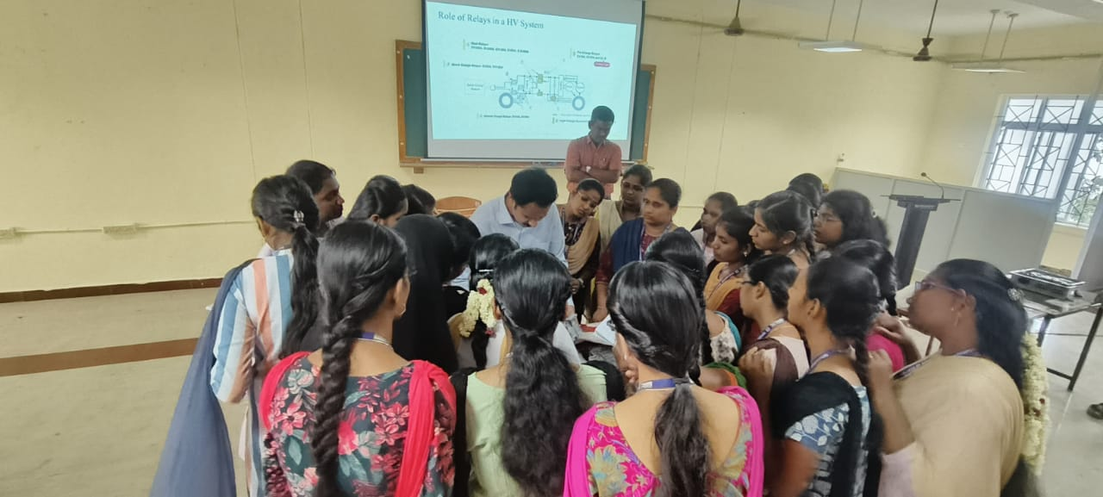
The discussion included definition and basic working principle of EVs, Comparison between ICE vehicles and Electric Vehicles, Importance of renewable energy integration with EVs, Role of EVs in reducing carbon emissions, Global EV trends and technological advancements.

The speaker also encouraged student participation by asking interactive questions related to EV case studies, EV design complexity, cost comparison, Tesla models, and common EV components. This interactive approach helped students to think critically and actively engage in the learning process.
Adding to insights, discussion including environmental benefits, lower operating costs, high energy efficiency, performance advantages, government incentives, charging infrastructure challenges, battery degradation, and high upfront costs. Students gained a balanced understanding of both the opportunities and limitations of EV technology.

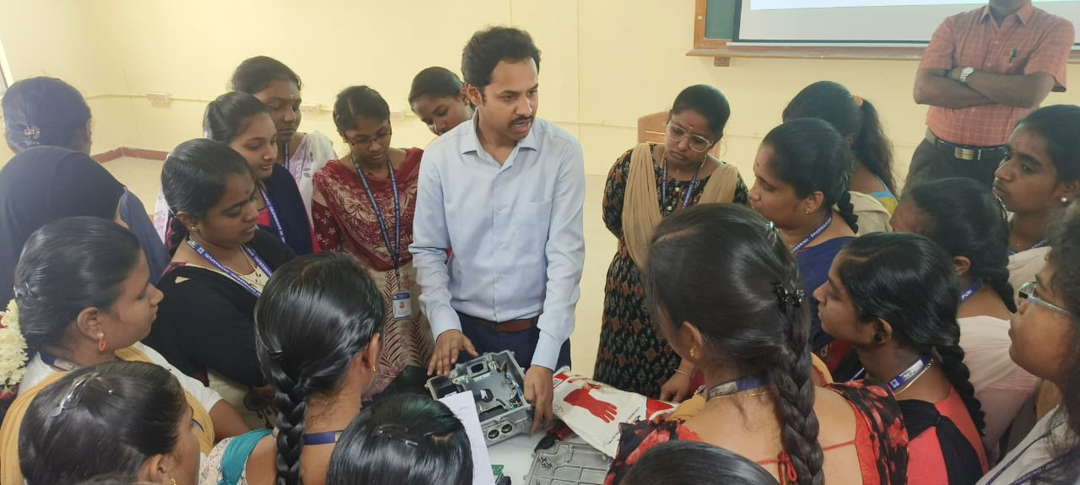
The resource person discussed major EV manufacturers in two-wheelers, three-wheelers, four-wheelers, buses, and commercial vehicles. Government initiatives like the FAME-II scheme were highlighted, along with the growth of charging infrastructure across India. Career opportunities for Electrical and Electronics Engineering students in EV sectors such as BMS engineering, motor control, power electronics, embedded systems, and smart grid integration were also explained.
Day 1 – Session 2 (Afternoon Session)
In the second session of Day 1, the technical architecture and internal components of Electric Vehicles were discussed. This session provided a deeper understanding of how different subsystems work together to power an EV. The resource person explained the major EV components with live demonstration, which includes Traction Battery Pack, Electric Motor, Onboard Charger, DC-DC Converter, Transmission System Auxiliary Battery. This session significantly improved students technical clarity regarding EV component integration and working mechanisms.

Day 2 – Session 1 (Morning Session)
The Day 2 started with advanced EV powertrain systems, safety aspects of traction inverter and high-voltage systems.
The traction inverter was discussed in detail as the heart of EV power electronics. The components of the inverter system including Battery DC input, EMI filter, Bus bars, DC link capacitor, Power modules (IGBT/MOSFET),Gate driver circuits, Current and voltage sensors, Resolver for rotor position, Aluminum housing and cooling system were explained,

The concept of switching frequency, efficiency improvement, and thermal management was well explained. Students understood how inverter performance directly affects EV acceleration, torque control, and efficiency.
Safety considerations in high-voltage systems, including Personal protective equipment (PPE), Grounding and insulation, Lockout/Tagout (LOTO) procedures, Use of insulated tools, Regular inspection and maintenance, Environmental safety practices were thoroughly discussed.

The session also covered PMSM motor specifications such as power rating, torque, speed, voltage, efficiency, and cooling methods. The importance of traction motor design in determining EV performance was explained clearly. This session strengthened students’ knowledge in power electronics and high-voltage safety practices, which are critical in EV engineering.

Day 2 – Session 2 (Afternoon Session)
The final session focused on practical exposure, testing standards, and real-time EV demonstration. The speaker explained safety standards, testing procedures, and regulatory compliance followed in EV manufacturing.
Students were given the opportunity to observe and experience live driving of an EV car. During the demonstration, the smooth acceleration, silent operation, regenerative braking, and performance characteristics were observed. The practical session helped students to connect theoretical concepts with real-world applications.
The workshop concluded with certificate distribution and closing remarks from faculty members and the resource person. Students expressed positive feedback and showed interest in pursuing further learning and projects in the EV domain.

.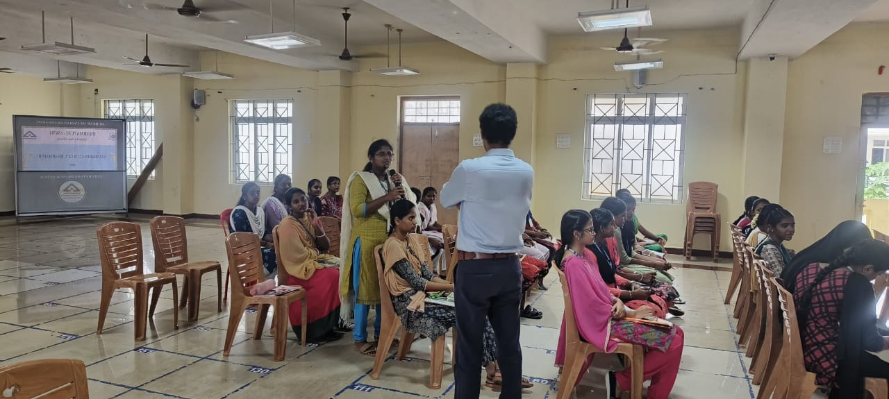

The workshop concluded with vote of thanks given by Prof. S. Nirmalkumar, AP/EEE.
.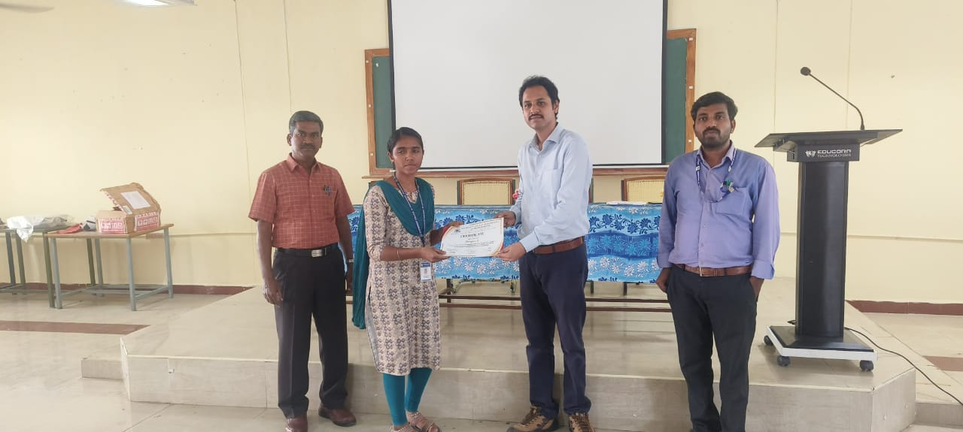The program was successfully conducted with the active support of the Principal, Head of the Department, and faculty members of the EEE Department of Government College of Engineering, Dharmapuri.

Coordinator Convenor Principal

