SI.No | NAME | BATCH/ DEPT | DESIGNATION | COMPANY NAME | PACKAGE | STUDENT PICTURE
DEPARTMENT OF ELECTRICAL AND ELECTRONICS ENGINEERING
No Of Students Placed: 49
Total No of Offers: 76
Internship:2

1. | GOMATHI G  613521105014 | 2021-25/EEE | GRADUATE APPRENTICE  TRAINEE | DELPHI- TVS  CHENNAI | 2.2 LPA | 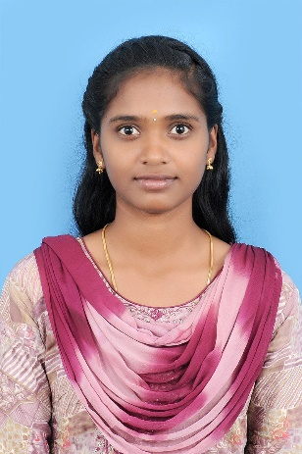
 |  |  | GRADUATE ENGINEER  TRAINEE | RENAULT NISSAN | 4 LPA
2. | KAJALNAJSHAMRIN S  613521105017 | 2021-25/EEE | GRADUATE APPRENTICE  TRAINEE | DELPHI- TVS  CHENNAI | 2.2 LPA | 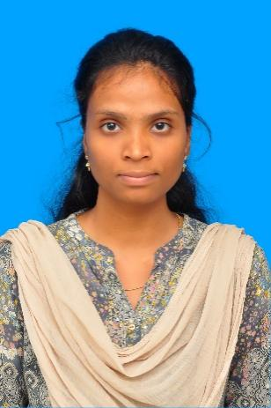
 |  |  | GRADUATE ENGINEER  TRAINEE | RENAULT NISSAN | 4 LPA
3. | YUVASRI M  613521105714 | 2021-25/EEE | GRADUATE APPRENTICE  TRAINEE | DELPHI- TVS  CHENNAI | 2.2 LPA | 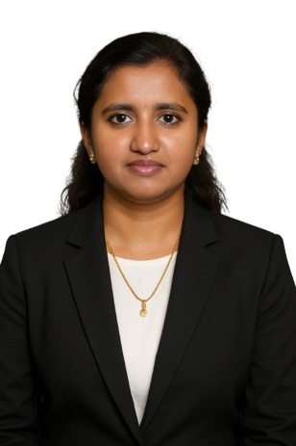
 |  |  | GRADUATE ENGINEER  TRAINEE | RENAULT NISSAN | 4 LPA
4. | KISHORESHANKAR M  613521105021 | 2021-25/EEE | ELECTRICAL TRAINEE ENGINEER | PETRO6 E&C  CHENNAI | 3.5 LPA | 
5. | AFREEN FARIAH M  613521105001 | 2021-25/EEE | GRADUATE APPRENTICE  TRAINEE | DELPHI- TVS  CHENNAI | 2.2 LPA | 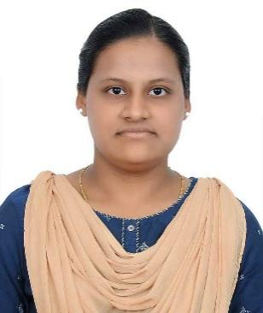
6. | AKALYA M  613521105002 | 2021-25/EEE | GRADUATE APPRENTICE  TRAINEE | DELPHI- TVS  CHENNAI | 2.2 LPA | 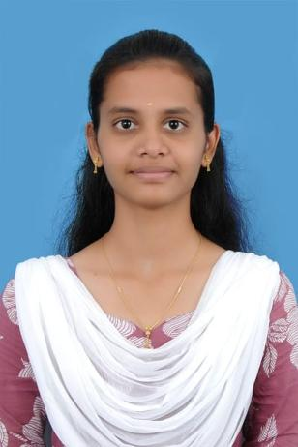
7. | AKASH S  613521105003 | 2021-25/EEE | GRADUATE APPRENTICE  TRAINEE | AQUASUB  COIMBATORE | 1.8 LPA | 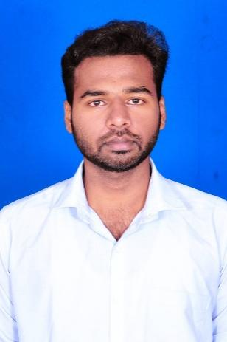
8. | ARUNADEVI A  613521105004 | 2021-25/EEE | GRADUATE APPRENTICE  TRAINEE | DELPHI- TVS  CHENNAI | 2.2 LPA | 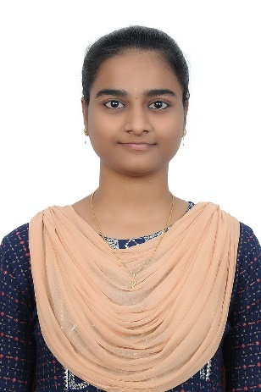
9. | BALAJI D  613521105005 | 2021-25/EEE | GRADUATE APPRENTICE  TRAINEE | AQUASUB  COIMBATORE | 1.8 LPA | 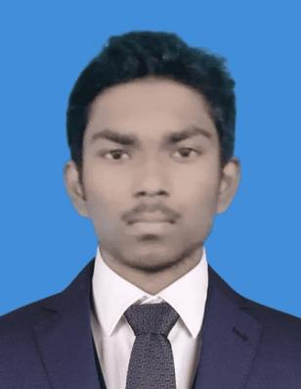
 |  |  |  | SCHAEFFLER-INDIA  HOSUR | 2.2 LPA
10. | BOOMIKA P  613521105007 | 2021-25/EEE | GRADUATE APPRENTICE  TRAINEE | DELPHI- TVS  CHENNAI | 2.2 LPA | 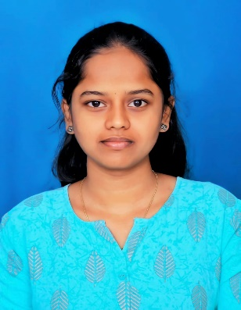
 |  |  |  | SCHAEFFLER INDIA  HOSUR | 2.2 LPA
11. | BRIGHTSON A  613521105008 | 2021-25/EEE | INTERNSHIP | QSPIDERS  BANGALORE | NIL | 
 |  |  | GRADUATE APPRENTICE  TRAINEE | SCHAEFFLER-INDIA  HOSUR | 2.2 LPA
12. | DEEPTHI S  613521105009 | 2021-25/EEE | GRADUATE APPRENTICE  TRAINEE | DELPHI- TVS  CHENNAI | 2.2 LPA | 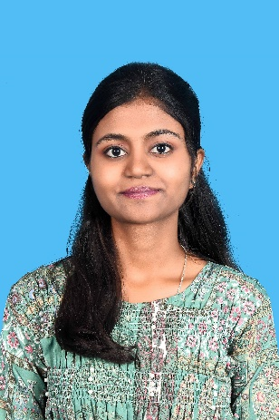
13. | DHARSHAN M  613521105010 | 2021-25/EEE | GRADUATE APPRENTICE  TRAINEE | DELPHI- TVS  CHENNAI | 2.2 LPA | 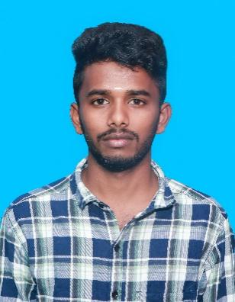
 |  |  |  | SCHAEFFLER INDIA  HOSUR | 2.2 LPA
14. | DHINESH R  613521105012 | 2021-25/EEE | GRADUATE APPRENTICE  TRAINEE | DELPHI- TVS  CHENNAI | 2.2 LPA | 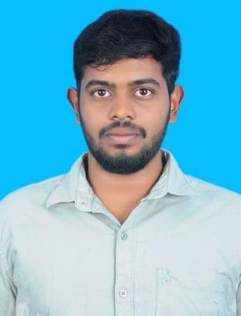
 |  |  |  | SCHAEFFLER INDIA  HOSUR | 2.2 LPA
15. | GOKULRAM M  613521105013 | 2021-25/EEE | GRADUATE APPRENTICE  TRAINEE | AQUASUB  COIMBATORE | 1.8 LPA | 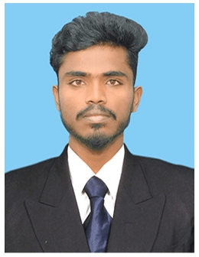
 |  |  |  | SCHAEFFLER INDIA  HOSUR | 2.2 LPA
16. | HARINATH P  613521105015 | 2021-25/EEE | GRADUATE APPRENTICE  TRAINEE | SCHAEFFLER-INDIA  HOSUR | 2.2 LPA | 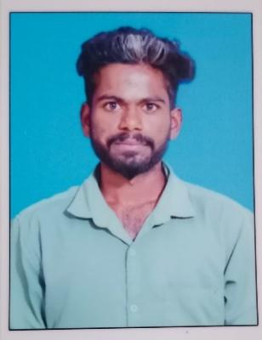
17. | JAYASHREE S  613521105016 | 2021-25/EEE | GRADUATE APPRENTICE  TRAINEE | DELPHI- TVS  CHENNAI | 2.2 LPA | 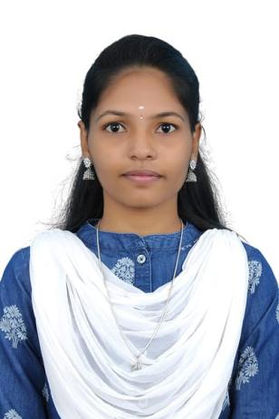
18. | KAVINAYA P  613521105020 | 2021-25/EEE | GRADUATE APPRENTICE  TRAINEE | DELPHI- TVS  CHENNAI | 2.2 LPA | 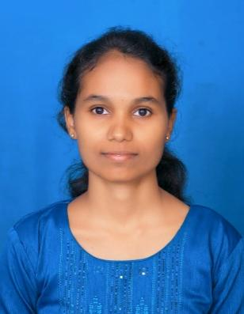
 |  |  |  | SCHAEFFLER INDIA  HOSUR | 2.2 LPA
18. | MOULIESWAR S  613521105023 | 2021-25/EEE | GRADUATE APPRENTICE  TRAINEE | DELPHI- TVS  CHENNAI | 2.2 LPA | 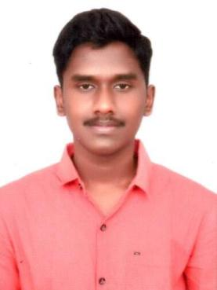
20. | NITHYA C  613521105027 | 2021-25/EEE | GRADUATE APPRENTICE  TRAINEE | DELPHI- TVS  CHENNAI | 2.2 LPA | 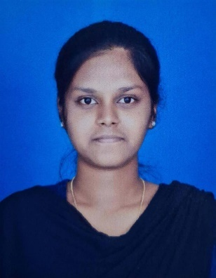
21. | POOJA S  613521105030 | 2021-25/EEE | GRADUATE APPRENTICE  TRAINEE | DELPHI- TVS  CHENNAI | 2.2 LPA | 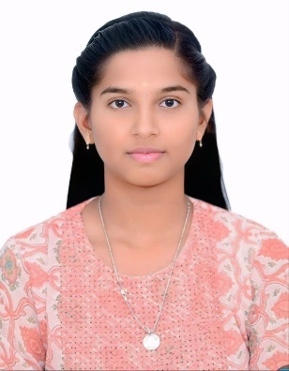
22. | POONKUZHALI T  613521105031 | 2021-25/EEE | GRADUATE APPRENTICE  TRAINEE | DELPHI- TVS  CHENNAI | 2.2 LPA | 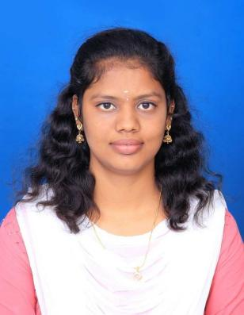
 |  |  |  | SCHAEFFLER INDIA  HOSUR | 2.2 LPA
23. | PRATHAP E  613521105032 | 2021-25/EEE | GRADUATE APPRENTICE  TRAINEE | DELPHI- TVS  CHENNAI | 2.2 LPA | 
24. | RAJAKUMARAN M  613521105033 | 2021-25/EEE | GRADUATE APPRENTICE  TRAINEE | SCHAEFFLER-INDIA  HOSUR | 2.2 LPA | 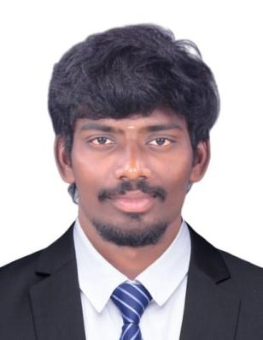
25. | RUDHRAN R  613521105034 | 2021-25/EEE | GRADUATE APPRENTICE  TRAINEE | DELPHI- TVS  CHENNAI | 2.2 LPA | 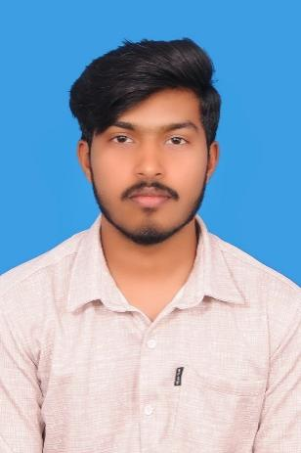
 |  |  |  | SCHAEFFLER INDIA  HOSUR | 2.2 LPA
26. | SATHISH M  613521105038 | 2021-25/EEE | GRADUATE APPRENTICE  TRAINEE | DELPHI- TVS  CHENNAI | 2.2 LPA | 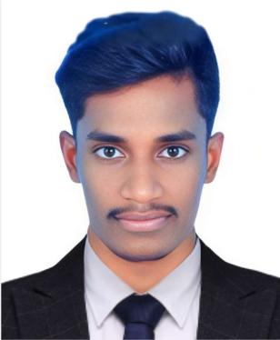
 |  |  |  | SCHAEFFLER INDIA  HOSUR | 2.2 LPA
27. | SHALINI S  613521105039 | 2021-25/EEE | GRADUATE APPRENTICE  TRAINEE | DELPHI- TVS  CHENNAI | 2.2 LPA | 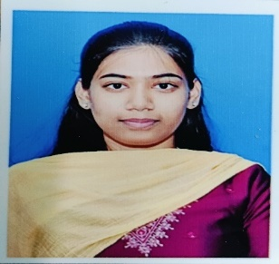
28. | SHIVANESH A  613521105040 | 2021-25/EEE | GRADUATE APPRENTICE  TRAINEE | AQUASUB  COIMBATORE | 1.8 LPA | 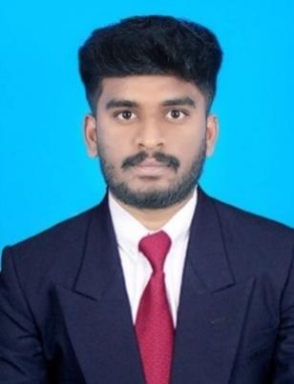
 |  |  |  | SCHAEFFLER INDIA  HOSUR | 2.2 LPA
29. | SOUNDARYA N  613521105041 | 2021-25/EEE | GRADUATE APPRENTICE  TRAINEE | SCHAEFFLER-INDIA  HOSUR | 2.2 LPA | 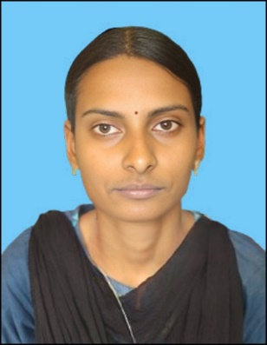
30. | SUBALAKSHMI R  613521105043 | 2021-25/EEE | INTERNSHIP | QSPIDERS  BANGALORE | NIL | 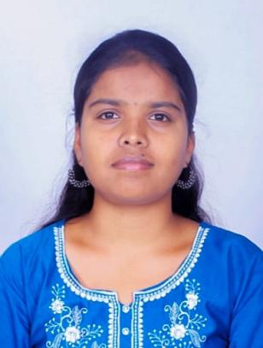
31. | SUMITHRA G  613521105044 | 2021-25/EEE | GRADUATE APPRENTICE  TRAINEE | SCHAEFFLER-INDIA  HOSUR | 2.2 LPA | 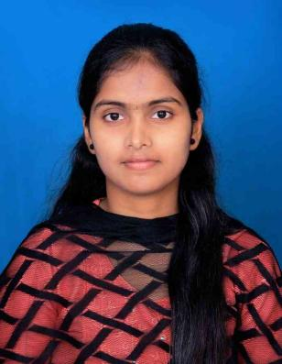
32. | SUVITHA M  613521105045 | 2021-25/EEE | GRADUATE APPRENTICE  TRAINEE | SCHAEFFLER-INDIA  HOSUR | 2.2 LPA | 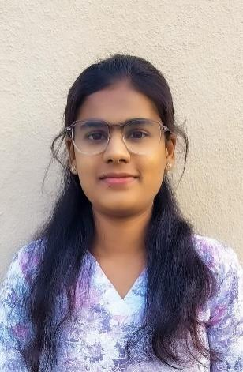
33. | THAMARAISELVAN B  613521105046 | 2021-25/EEE | GRADUATE APPRENTICE  TRAINEE | DELPHI- TVS  CHENNAI | 2.2 LPA | 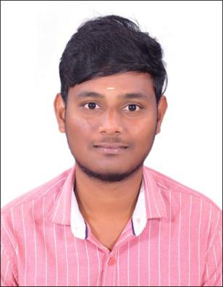
 |  |  |  | SCHAEFFLER-INDIA  HOSUR | 2.2 LPA
34. | THOLKAPPIYAN G  613521105047 | 2021-25/EEE | GRADUATE APPRENTICE  TRAINEE | AQUASUB  COIMBATORE | 1.8 LPA | 
 |  |  |  | SCHAEFFLER INDIA  HOSUR | 2.2 LPA
35. | VAITHEESH M  613521105048 | 2021-25/EEE | GRADUATE APPRENTICE  TRAINEE | DELPHI- TVS  CHENNAI | 2.2 LPA | 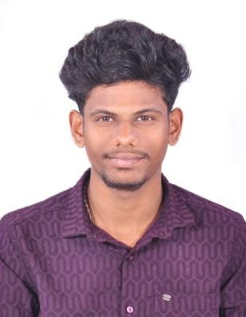
 |  |  |  | SCHAEFFLER-INDIA  HOSUR | 2.2 LPA
36. | VELMURUGAN R  613521105049 | 2021-25/EEE | GRADUATE APPRENTICE  TRAINEE | AQUASUB  COIMBATORE | 1.8 LPA | 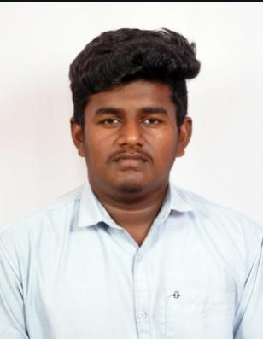
 |  |  |  | SCHAEFFLER-INDIA  HOSUR | 2.2 LPA
37. | VIJAY S  613521105302 | 2021-25/EEE | GRADUATE APPRENTICE  TRAINEE | AQUASUB  COIMBATORE | 1.8 LPA | 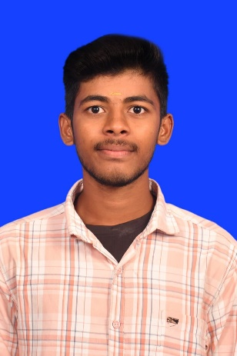
 |  |  |  | SCHAEFFLER-INDIA  HOSUR | 2.2 LPA
38. | VISHNU P  613521105702 | 2021-25/EEE | GRADUATE APPRENTICE  TRAINEE | AQUASUB  COIMBATORE | 1.8 LPA | 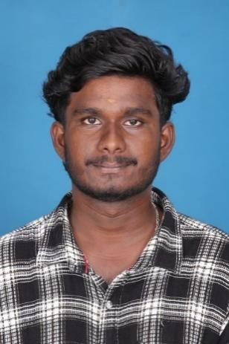
 |  |  |  | SCHAEFFLER-INDIA  HOSUR | 2.2 LPA
39. | SARAN K  613521105703 | 2021-25/EEE | GRADUATE APPRENTICE  TRAINEE | DELPHI- TVS  CHENNAI | 2.2 LPA | 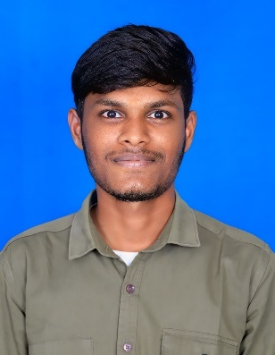
 |  |  |  | SCHAEFFLER INDIA  HOSUR | 2.2 LPA
40. | PRAVEEN KUMAR M  613521105704 | 2021-25/EEE | GRADUATE APPRENTICE  TRAINEE | AQUASUB  COIMBATORE | 1.8 LPA | 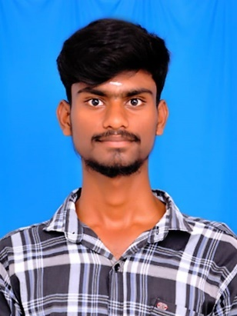
 |  |  |  | SCHAEFFLER-INDIA  HOSUR | 2.2 LPA
41. | HARI PRADHAP A  613521105705 | 2021-25/EEE | GRADUATE APPRENTICE  TRAINEE | AQUASUB  COIMBATORE | 1.8 LPA | 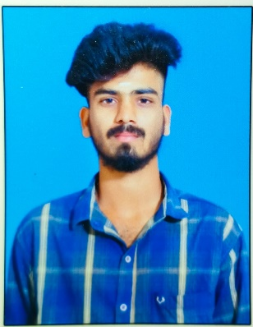
 |  |  |  | SCHAEFFLER INDIA  HOSUR | 2.2 LPA
42. | SIVAMANICKAVEL P K  613521105707 | 2021-25/EEE | GRADUATE APPRENTICE  TRAINEE | SCHAEFFLER INDIA  HOSUR | 2.2 LPA | 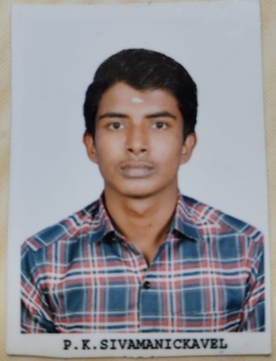
43. | ARUNKUMAR B  613521105708 | 2021-25/EEE | GRADUATE APPRENTICE  TRAINEE | AQUASUB  COIMBATORE | 1.8 LPA | 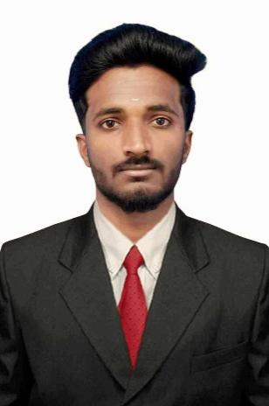
 |  |  |  | SCHAEFFLER-INDIA  HOSUR | 2.2 LPA
44. | JAGADISHKUMAR S  613521105709 | 2021-25/EEE | GRADUATE APPRENTICE  TRAINEE | SCHAEFFLER-INDIA  HOSUR | 2.2 LPA | 
45. | SUNIL KUMAR M  613521105710 | 2021-25/EEE | GRADUATE APPRENTICE  TRAINEE | AQUASUB  COIMBATORE | 1.8 LPA | 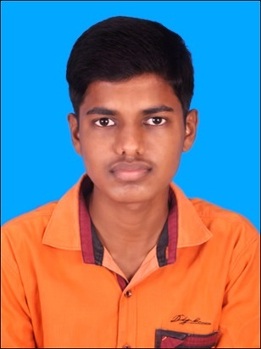
 |  |  |  | SCHAEFFLER-INDIA  HOSUR | 2.2 LPA
46. | JANA S  613521105711 | 2021-25/EEE | GRADUATE APPRENTICE  TRAINEE | SCHAEFFLER-INDIA  HOSUR | 2.2 LPA | 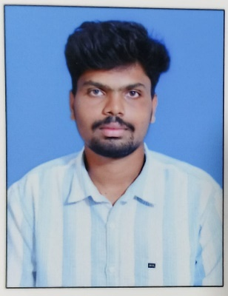
47. | RAJASHREE S  613521105712 | 2021-25/EEE | GRADUATE APPRENTICE  TRAINEE | SCHAEFFLER-INDIA  HOSUR | 2.2 LPA | 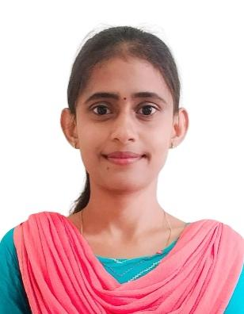
48. | GOMATHI M  613521105713 | 2021-25/EEE | GRADUATE APPRENTICE  TRAINEE | DELPHI- TVS  CHENNAI | 2.2 LPA | 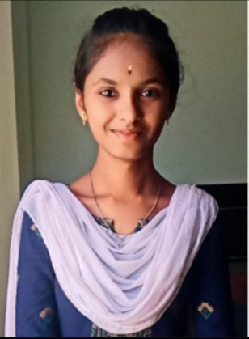
 |  |  |  | SCHAEFFLER-INDIA  HOSUR | 2.2 LPA
49. | MANIMARAN R  613521105715 | 2021-25/EEE | GRADUATE APPRENTICE  TRAINEE | AQUASUB  COIMBATORE | 1.8 LPA | 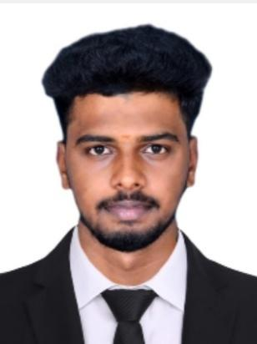
 |  |  |  | SCHAEFFLER INDIA  HOSUR | 2.2 LPA

