
GOVERNMENT COLLEGE OF ENGINEERING, DHARMAPURI

PLACEMENT DETAILS(2021-2025BATCH)

SL.NO | NAME | BATCH/  DEPT | DESIGNATION | COMPANY NAME | PACKAGE | STUDENT PICTURE
DEPARTMENT OF ELECTRONICS AND COMMUNICATION ENGINEERING
No Of Students Placed: 32
Total No of Offers: 48
Internship:13
 | AADHITYAN C  (613520106001) | 2021-  25/ECE | Internship | VERNAEDGE , BANGALORE | NIL | INCLUDEPICTURE "C:\\Users\\Deepika Padma\\Downloads\\Aadhityan C .jpg" \* MERGEFORMATINET INCLUDEPICTURE "C:\\Users\\Deepika Padma\\Downloads\\Aadhityan C .jpg" \* MERGEFORMATINET INCLUDEPICTURE "C:\\Users\\Deepika Padma\\Downloads\\Aadhityan C .jpg" \* MERGEFORMATINET INCLUDEPICTURE "C:\\Users\\Downloads\\Aadhityan C .jpg" \* MERGEFORMATINET INCLUDEPICTURE "C:\\Users\\Downloads\\Aadhityan%20C%20.jpg" \* MERGEFORMATINET INCLUDEPICTURE "C:\\Users\\Downloads\\Aadhityan%20C%20.jpg" \* MERGEFORMATINET INCLUDEPICTURE "C:\\Users\\Downloads\\Aadhityan%2520C%2520.jpg" \* MERGEFORMATINET INCLUDEPICTURE "C:\\Downloads\\Aadhityan%2520C%2520.jpg" \* MERGEFORMATINET 
 | AADHITYAN C  (613520106001) | 2021-  25/ECE | Graduate Engineer Trainee | DELPHI TVS , CHENNAI | 2.2 LPA
 | AJAY S  (631521106002) | 2021-  25/ECE | Graduate Engineer Trainee | SCHAEFFLER LIMITED INDIA HOSUR | 2.5 LPA | 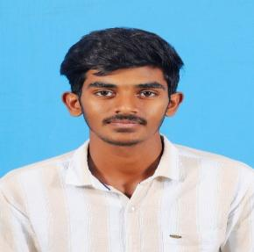
 | BALAMURALI K  (613521106006) | 2021-  25/ECE | Graduate Engineer Trainee | SCHAEFFLER LIMITED INDIA HOSUR | 2.5 LPA | 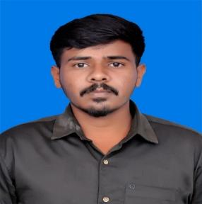
 | ARTHI S  (613521106005) | 2021-  25/ECE | Graduate Engineer Trainee | DELPHI TVS , CHENNAI | 2.2 LPA | 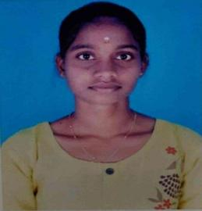
 | DIVYA SRI.D.E  (613521106009) | 2021-  25/ECE | Graduate Engineer Trainee | SCHAEFFLER LIMITED INDIA HOSUR | 2.5 LPA | INCLUDEPICTURE "C:\\Users\\Deepika Padma\\Downloads\\Divya Sri D E .jpg" \* MERGEFORMATINET INCLUDEPICTURE "C:\\Users\\Deepika Padma\\Downloads\\Divya Sri D E .jpg" \* MERGEFORMATINET INCLUDEPICTURE "C:\\Users\\Deepika Padma\\Downloads\\Divya Sri D E .jpg" \* MERGEFORMATINET INCLUDEPICTURE "C:\\Users\\Downloads\\Divya Sri D E .jpg" \* MERGEFORMATINET INCLUDEPICTURE "C:\\Users\\Downloads\\Divya%20Sri%20D%20E%20.jpg" \* MERGEFORMATINET INCLUDEPICTURE "C:\\Users\\Downloads\\Divya%20Sri%20D%20E%20.jpg" \* MERGEFORMATINET INCLUDEPICTURE "C:\\Users\\Downloads\\Divya%2520Sri%2520D%2520E%2520.jpg" \* MERGEFORMATINET INCLUDEPICTURE "C:\\Downloads\\Divya%2520Sri%2520D%2520E%2520.jpg" \* MERGEFORMATINET 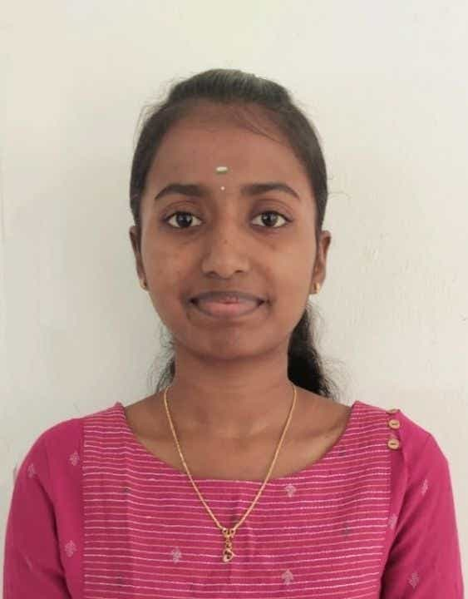
 | DIVYA SRI.D.E  (613521106009) | 2021-25  /ECE | Graduate Engineer Trainee | DELPHI TVS , CHENNAI | 2.2 LPA
 | GAYATHRI S  (613521106010) | 2021-  25/ECE | Graduate Engineer Trainee | DELPHI TVS , CHENNAI | 2.2 LPA | 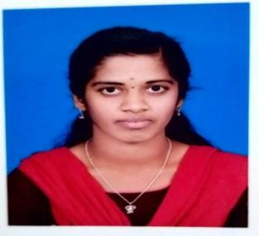
 | GAYATHRI S  (613521106010) | 2021-  25/ECE | Graduate Engineer Trainee | SCHAEFFLER LIMITED INDIA HOSUR | 2.5 LPA
 | HARISH R  (613521106014) | 2021-  25/ECE | INTERNSHIP | Q SPIDERS , BANGLALORE | NIL | 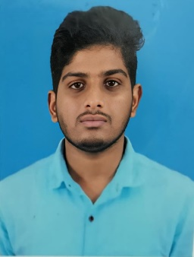
 | KALIDASS R  (613521106015) | 2021-  25/ECE | INTERNSHIP | VERNAEDGE , BANGALORE | NIL | 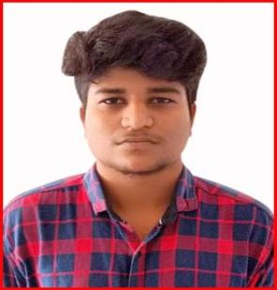
 | KALIDASS R  (613521106015) | 2021-  25/ECE | Graduate Engineer Trainee | SCHAEFFLER LIMITED INDIA HOSUR | 2.5 LPA
 | KAMESHWARAN K  (613521106016) | 2021-  25/ECE | INTERNSHIP | Q SPIDERS , BANGLALORE | NIL | 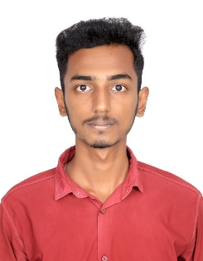
 | KOKIL K R  (613521106018) | 2021-  25/ECE | Graduate Engineer Trainee | SCHAEFFLER LIMITED INDIA HOSUR | 2.5 LPA | 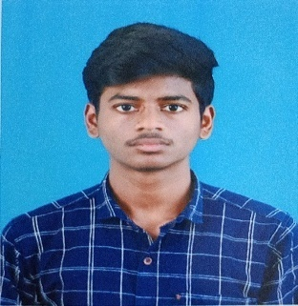
 | KOKIL K R  (613521106018) | 2021-  25/ECE | Graduate Engineer Trainee | DELPHI TVS , CHENNAI | 2.2 LPA
 | KOWSIK  PRASANNA. N  (613521106019) | 2021-  25/ECE | Graduate Engineer Trainee | SCHAEFFLER LIMITED INDIA HOSUR | 2.5 LPA | 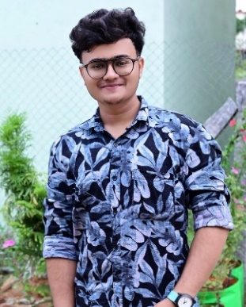
 | KOWSIK  PRASANNA. N  (613521106019) | 2021-  25/ECE | Graduate Engineer Trainee | DELPHI TVS , CHENNAI | 2.2 LPA
 | LINGESHWARAN G  (613521106020) | 2021-  25/ECE | Graduate Engineer Trainee | SCHAEFFLER LIMITED INDIA HOSUR | 2.5 LPA | 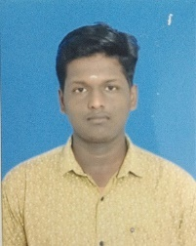
 | MOHANAKUMAR S  (613521106023) | 2021-  25/ECE | INTERNSHIP | Q SPIDERS , BANGLALORE | NIL | 
 | MONIKA.S  (613521106024) | 2021-  25/ECE | Graduate Engineer Trainee | SCHAEFFLER LIMITED INDIA HOSUR | 2.5 LPA | 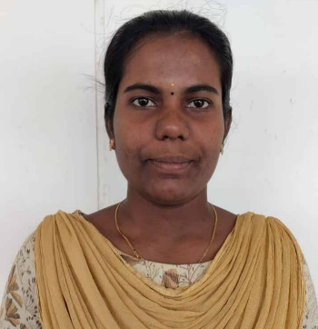
 | MONIKA.S  (613521106024) | 2021-25/ECE | Graduate Engineer Trainee | DELPHI TVS , CHENNAI | 2.2 LPA
 | NITHISH S V  (613521106029) | 2021-  25/ECE | Graduate Engineer Trainee | SCHAEFFLER LIMITED INDIA HOSUR | 2.5 LPA | 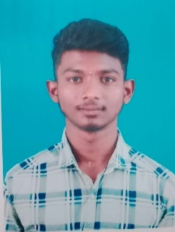
 | MYTHILI.M  (613521106025) | 2021-  25/ECE | Graduate Engineer Trainee | SCHAEFFLER LIMITED INDIA HOSUR | 2.5 LPA | 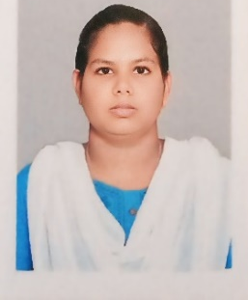
 | MYTHILI.M  (613521106025) | 2021-  25/ECE | Graduate Engineer Trainee | DELPHI TVS , CHENNAI | 2.2 LPA
 | PAVITHRA.V  (613521106031) | 2021-  25/ECE | Graduate Engineer Trainee | SCHAEFFLER LIMITED INDIA HOSUR | 2.5 LPA | 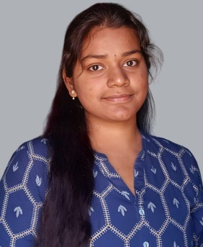
 | PAVITHRA.V  (613521106031) | 2021-25/ECE | Graduate Engineer Trainee | DELPHI TVS , CHENNAI | 2.2 LPA
 | PRADEESH M  (613521106033) | 2021-  25/ECE | INTERNSHIP | Q SPIDERS , BANGLALORE | NIL | 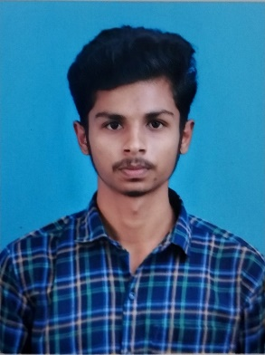
 | PRAVEEN P  (613521106034) | 2021-  25/ECE | INTERNSHIP | Q SPIDERS , BANGLALORE | NIL | 
 | RENUGA.R  (613521106037) | 2021-  25/ECE | INTERNSHIP | NTT DATA SERVICE, CHENNAI | NIL | 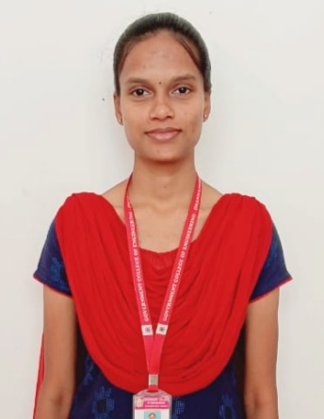
 | RENUGA.R  (613521106037) | 2021-  25/ECE | Graduate Engineer Trainee | DELPHI TVS , CHENNAI | 2.2 LPA
 | RENUGA.R  (613521106037) | 2021-  25/ECE | Graduate Engineer Trainee | SCHAEFFLER LIMITED INDIA HOSUR | 2.5 LPA
 | SANTHOSH SIVAN C  (613521106038) | 2021-  25/ECE | INTERNSHIP | Q SPIDERS , BANGLALORE | NIL | 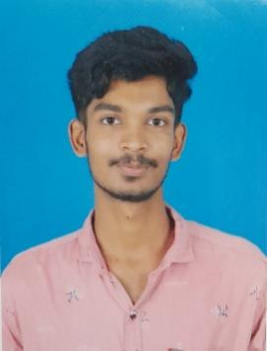
 | SARAVANAN.S  (613521106039) | 2021-  25/ECE | Graduate Engineer Trainee | NAAN MUDHALVAN FUTURE LEADERSHIP PROGRAM, CHENNAI | 1.8 LPA | 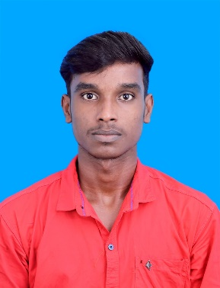
 | SARAVANAN.S  (613521106039) | 2021-  25/ECE | Graduate Engineer Trainee | DELPHI TVS , CHENNAI | 2.2 LPA
 | SASIKALA V  (613521106040) | 2021-  25/ECE | Graduate Engineer Trainee | SCHAEFFLER LIMITED INDIA HOSUR | 2.5 LPA | 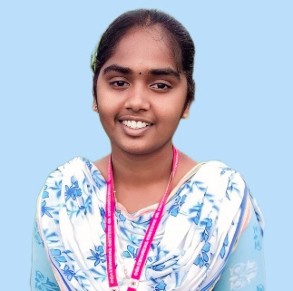
 | SASIKALA V  (613521106040) | 2021-25/ECE | Graduate Engineer Trainee | DELPHI TVS , CHENNAI | 2.2 LPA
 | THARAGINI M  (613521106046) | 2021-  25/ECE | Graduate Engineer Trainee | DELPHI TVS , CHENNAI | 2.2 LPA | 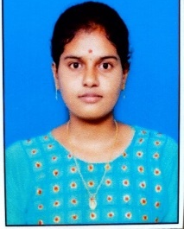
25. | TREESHAA A  (613521106047) | 2021-  25/ECE | Graduate Engineer Trainee | SCHAEFFLER LIMITED INDIA HOSUR | 2.5 LPA | 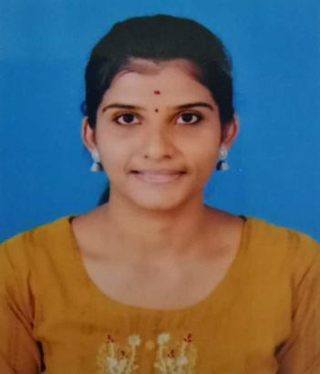
25. | TREESHAA A  (613521106047) | 2021-25/ECE | Graduate Engineer Trainee | DELPHI TVS , CHENNAI | 2.2 LPA
26. | VINITHA M  (613521106050) | 2021-  25/ECE | Graduate Engineer Trainee | SCHAEFFLER LIMITED INDIA HOSUR | 2.5 LPA | 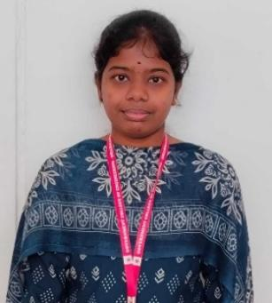
26. | VINITHA M  (613521106050) | 2021-25/ECE | Graduate Engineer Trainee | DELPHI TVS , CHENNAI | 2.2 LPA
 | YOGASRI A  (613521106051) | 2021-  25/ECE | Internship | VERNAEDGE , BANGALORE | Nil | 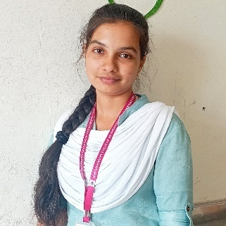
 | YOGASRI A  (613521106051) | 2021-  25/ECE | Graduate Engineer Trainee | DELPHI TVS , CHENNAI | 2.2 LPA
 | YOGASRI A  (613521106051) | 2021-  25/ECE | Network Engineer | SILICON HOUSE , COIMBATORE | 2.5 LPA
 | YOGASRI A  (613521106051) | 2021-  25/ECE | Inside sales Representative | GLOW LOGICS , BANGALORE | 4.2 LPA
 | MONISHA.M  (613521106307) | 2021-  25/ECE | Graduate Engineer Trainee | SCHAEFFLER LIMITED INDIA HOSUR | 2.5 LPA | 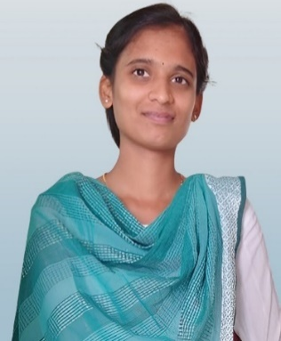
 | MONISHA.M  (613521106307) | 2021-  25/ECE | Graduate Engineer Trainee | DELPHI TVS , CHENNAI | 2.2 LPA
 | CHINNADURAI V  (613521106701) | 2021-  25/ECE | Internship | VERNAEDGE , BANGALORE | NIL | 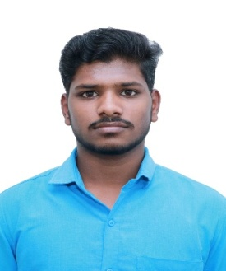
 | CHINNADURAI V  (613521106701) | 2021-  25/ECE | Graduate Engineer Trainee | DELPHI TVS , CHENNAI | 2.2 LPA
 | PRABAVATHI. S  (613521106310) | 2021-  25/ECE | Internship | APPIN TECHNOLOGY , COIMBATORE | NIL | 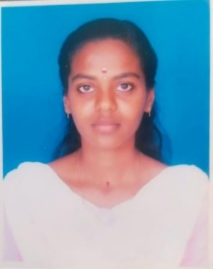
 | PRIYA DHARSHINI P  (613521106311) | 2021-  25/ECE | Graduate Engineer Trainee | SCHAEFFLER LIMITED INDIA HOSUR | 2.5 LPA | 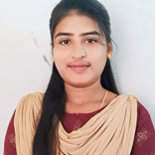
 | PRIYA DHARSHINI P  (613521106311) | 2021-  25/ECE | Business Development Associate | SKILL INTERN , BANGALORE | 4.2 LPA
 | BHUVANASUNDHAR R  (613521106303) | 2021-  25 / ECE | Graduate Engineer Trainee | SCHAEFFLER LIMITED INDIA HOSUR | 2.5 LPA | 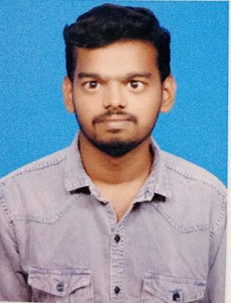
 | GOKUL M  (613521106304) | 2021-  25/ECE | Graduate Engineer Trainee | SCHAEFFLER LIMITED INDIA HOSUR | 2.5 LPA | 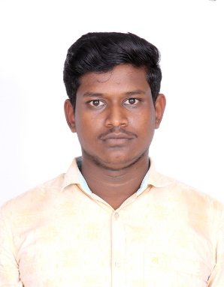
 | CHANDRU S  (613521106702) | 2021-  25/ECE | Graduate Engineer Trainee | SCHAEFFLER LIMITED INDIA HOSUR | 2.5 LPA | 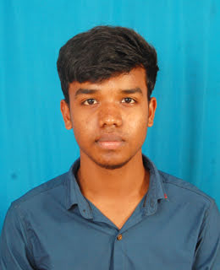
 | LOKESH M  (613521106703) | 2021-  25/ECE | Graduate Engineer Trainee | SCHAEFFLER LIMITED INDIA HOSUR | 2.5 LPA | 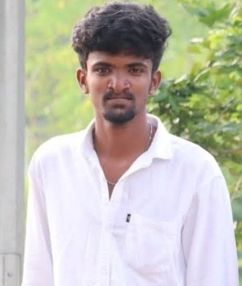
 | HARIHARAN S  (61352110305) | 2021-  25/ECE | Graduate Engineer Trainee | SCHAEFFLER LIMITED INDIA HOSUR | 2.5 LPA
 | HARI SANKAR J  (613521106306) | 2021-  25/ECE | Graduate Engineer Trainee | SCHAEFFLER LIMITED INDIA HOSUR | 2.5 LPA | 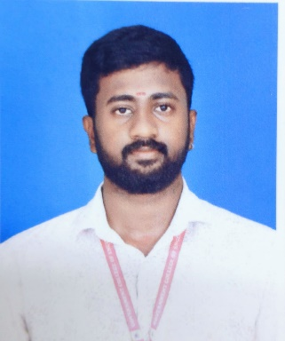
 | SANJAY. S  (613521106704) | 2021-  25/ECE | Business Development Associate | SKILL INTERN , BANGALORE | 4.2 LPA | 
 | HARIHARAN R  (613521106503) | 2021-  25/ECE | Graduate Engineer Trainee | SCHAEFFLER LIMITED INDIA HOSUR | 2.5 LPA | 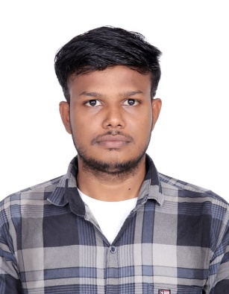
 | SEMBARUTHI S  (613521106504) | 2021-  25/ECE | INTERNSHIP | APPIN TECHNOLOGY , COIMBATORE | NIL | 