GOVERNMENT COLLEGE OF ENGINEERING DHARMAPURI

PLACEMENT DETAILS ( 2021 – 2025 BATCH)

DEPARTMENT OF COMPUTER SCIENCE AND ENGINEERING

NO OF STUDENTS PLACED :36
TOTAL NO OF OFFERS :43
INTERNSHIP:20

SL.NO | NAME | BATCH/  DEPT | DESIGNATION | COMPANY NAME | PACKAGE | STUDENT PICTURE
 | KEERTHANA V (613521104014) | 2021-25/CSE | SYSTEM ENGINEER | INFOSYS | 3.2LPA | 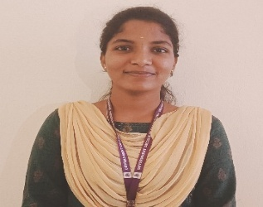
 | KEERTHANA V (613521104014) | 2021-25/CSE | BDA | SKILL INTERN PVT LTD  BANGALORE | 4.2 LPA
 | KEERTHANA V (613521104014) | 2021-25/CSE | INTERNSHIP | QSPIDERS  BANGALORE. | NIL
 | SHENJIN S A SOLOMON (613521104043) | 2021-25/CSE | BDA | SKILL INTERN PVT LTD  BANGALORE | 4.2 LPA | 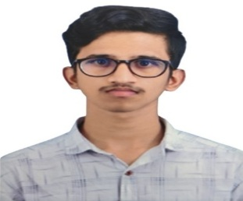
 | SHENJIN S A SOLOMON (613521104043) | 2021-25/CSE | INTERNSHIP | QSPIDERS  BANGALORE. | NIL
 | SHENJIN S A SOLOMON (613521104043) | 2021-25/CSE | INTERNSHIP | VENZO TECHNOLOGIES | NIL
 | NIVEDHA S (613521104022) | 2021-25/CSE | BDA | SKILL INTERN PVT LTD  BANGALORE | 4.2 LPA | 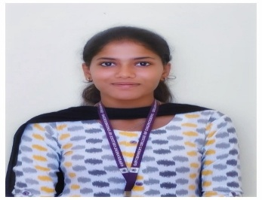
 | NIVEDHA S (613521104022) | 2021-25/CSE | INTERNSHIP | QSPIDERS  BANGALORE. | NIL
 | RAHUL M  (613521104031) | 2021-25/CSE | BDA | SKILL INTERN PVT LTD  BANGALORE | 4.2 LPA | 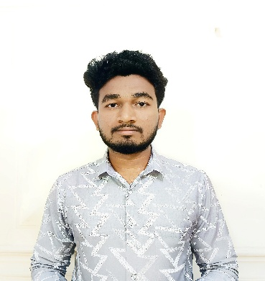
 | RAHUL M  (613521104031) | 2021-25/CSE | INTERNSHIP | QSPIDERS  BANGALORE. | NIL
 | SAKTHIVEL K  (613521104037) | 2021-25/CSE | BDA | SKILL INTERN PVT LTD  BANGALORE | 4.2 LPA | 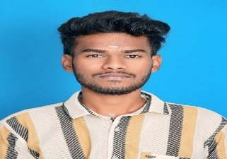
 | SAKTHIVEL K  (613521104037) | 2021-25/CSE | INTERNSHIP | QSPIDERS  BANGALORE. | NIL
 | VISHNU PRASATH A  (613521104312) | 2021-25/CSE | BDA | SKILL INTERN PVT LTD  BANGALORE | 4.2 LPA | 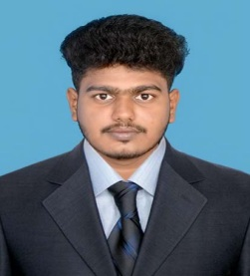
 | VISHNU PRASATH A  (613521104312) | 2021-25/CSE | INTERNSHIP | QSPIDERS  BANGALORE. | NIL
 | KALIYAMOORTHI P  (613521104010) | 2021-25/CSE | GRADUATE ENGINEER  TRAINEE | SCHAEFFLER-INDIA  HOSUR | 2.2 LPA | 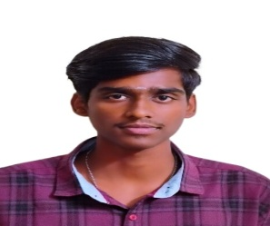
 | MOHAMED THOWFIC.M  (613521104018) | 2021-25/CSE | INTERNSHIP | QSPIDERS  BANGALORE. | NIL | 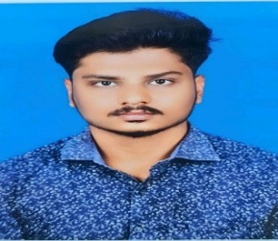
 | PRIYA S  (613521104030) | 2021-25/CSE | INTERNSHIP | QSPIDERS  BANGALORE. | NIL | 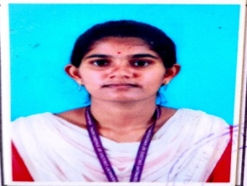
 | RAJESH R  (613521104032) | 2021-25/CSE | TRAINEE | ADMINDROID  CHENNAI | 4 LPA | 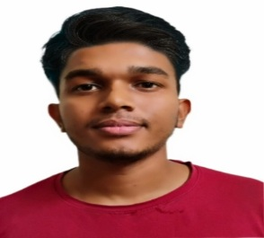
 | RAJESH R  (613521104032) | 2021-25/CSE | INTERNSHIP | QSPIDERS  BANGALORE. | NIL
 | TAMIL KUMARAN B  (613521104701) | 2021-25/CSE | GRADUATE ENGINEER  TRAINEE | SCHAEFFLER-INDIA  HOSUR. | 2.2 LPA | 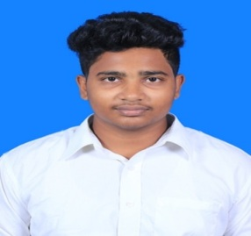
 | TAMIL KUMARAN B  (613521104701) | 2021-25/CSE | INTERNSHIP | QSPIDERS  BANGALORE. | NIL
 | GOPIKA P  (613521104007) | 2021-25/CSE | INTERNSHIP | QSPIDERS  BANGALORE. | NIL | 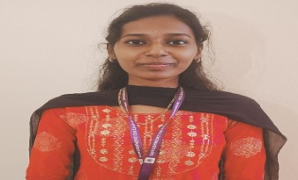
 | ABINAYA S (613521104002) | 2021-25/CSE | INTERNSHIP | QSPIDERS  BANGALORE | NIL | 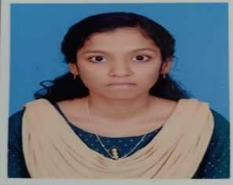
 | DHANALAXSHMI S (613521104006) | 2021-25/CSE | INTERNSHIP | QSPIDERS  BANGALORE | NIL | 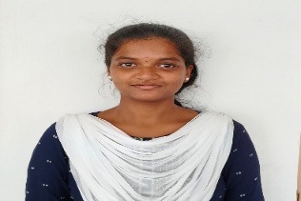
 | RAMPRIYAA R (613521104034) | 2021-25/CSE | GRADUATE ENGINEER  TRAINEE | SCHAEFFLER-INDIA  HOSUR | 2.2 LPA | 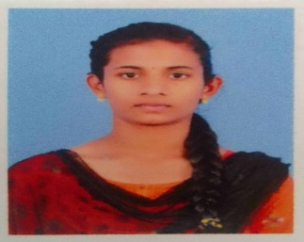
 | RAMPRIYAA R (613521104034) | 2021-25/CSE | INTERNSHIP | QSPIDERS  BANGALORE | NIL
 | AARTHI LAKSHMI. R (613521104001) | 2021-25/CSE | GRADUATE ENGINEER  TRAINEE | SCHAEFFLER-INDIA  HOSUR | 2.2 LPA | 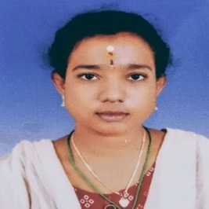
 | AARTHI LAKSHMI. R (613521104001) | 2021-25/CSE | XML Editor | Gold Win Tech | 2.2 LPA
 | JANANI KS (613521104009) | 2021-25/CSE | GRADUATE ENGINEERTRAINEE | SCHAEFFLER-INDIA,HOSUR | 2.2 LPA | 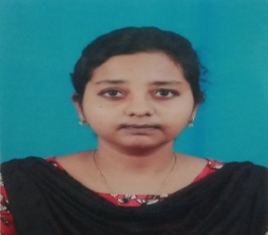
 | JANANI KS (613521104009) | 2021-25/CSE | XML Editor | Gold Win Tech | 2.2 LPA
 | PREMA M (613521104029) | 2021-25/CSE | GRADUATE ENGINEER TRAINEE | SCHAEFFLER-INDIA,HOSUR | 2.2 LPA | 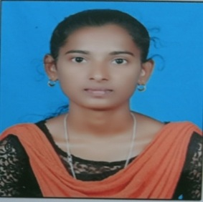
 | PREMA M (613521104029) | 2021-25/CSE | XML Editor | Gold Win Tech | 2.2 LPA
 | RAJPRIYA M (613521104033) | 2021-25/CSE | GRADUATE ENGINEER TRAINEE | SCHAEFFLER-INDIA,HOSUR | 2.2 LPA | 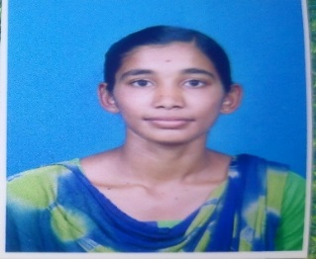
 | RAJPRIYA M (613521104033) | 2021-25/CSE | XML Editor | Gold Win Tech | 2.2 LPA
 | RITHIKA S (613521104035) | 2021-25/CSE | INTERNSHIP | QSPIDERS  BANGALORE. | NIL | 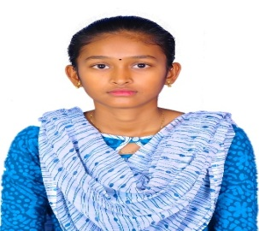
 | RITHIKA S (613521104035) | 2021-25/CSE | GRADUATE ENGINEER  TRAINEE | SCHAEFFLER-INDIA  HOSUR | 2.2 LPA
 | RITHIKA S (613521104035) | 2021-25/CSE | XML Editor | Gold Win Tech | 2.2 LPA
 | AMSAVENI K (613521104301) | 2021-25/CSE | GRADUATE ENGINEER  TRAINEE | SCHAEFFLER-INDIA  HOSUR | 2.2 LPA | 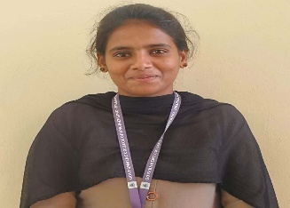
 | LOKESHWARI.S  (613521104016) | 2021-25/CSE | GRADUATE ENGINEER  TRAINEE | SCHAEFFLER-INDIA  HOSUR | 2.2 LPA | 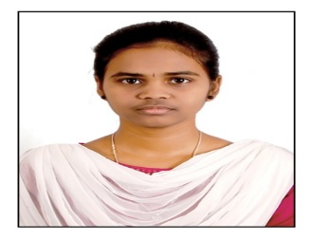
 | BRINDHA P (61352110501) | 2021-25/CSE | GRADUATE ENGINEER  TRAINEE | SCHAEFFLER-INDIA  HOSUR | 2.2 LPA | 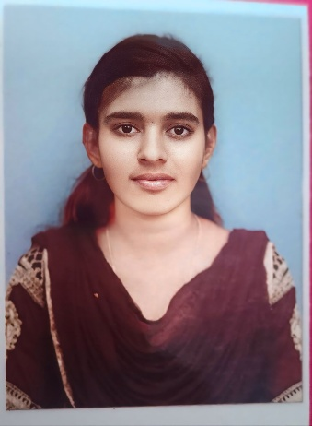
 | MANIKANDAN G (613521104307) | 2021-25/CSE | GRADUATE ENGINEER  TRAINEE | SCHAEFFLER-INDIA  HOSUR | 2.2 LPA | 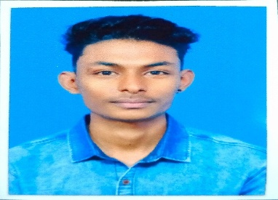
 | ASWIN G  (613521104302) | 2021-25/CSE | GRADUATE ENGINEER  TRAINEE | SCHAEFFLER-INDIA  HOSUR | 2.2 LPA | 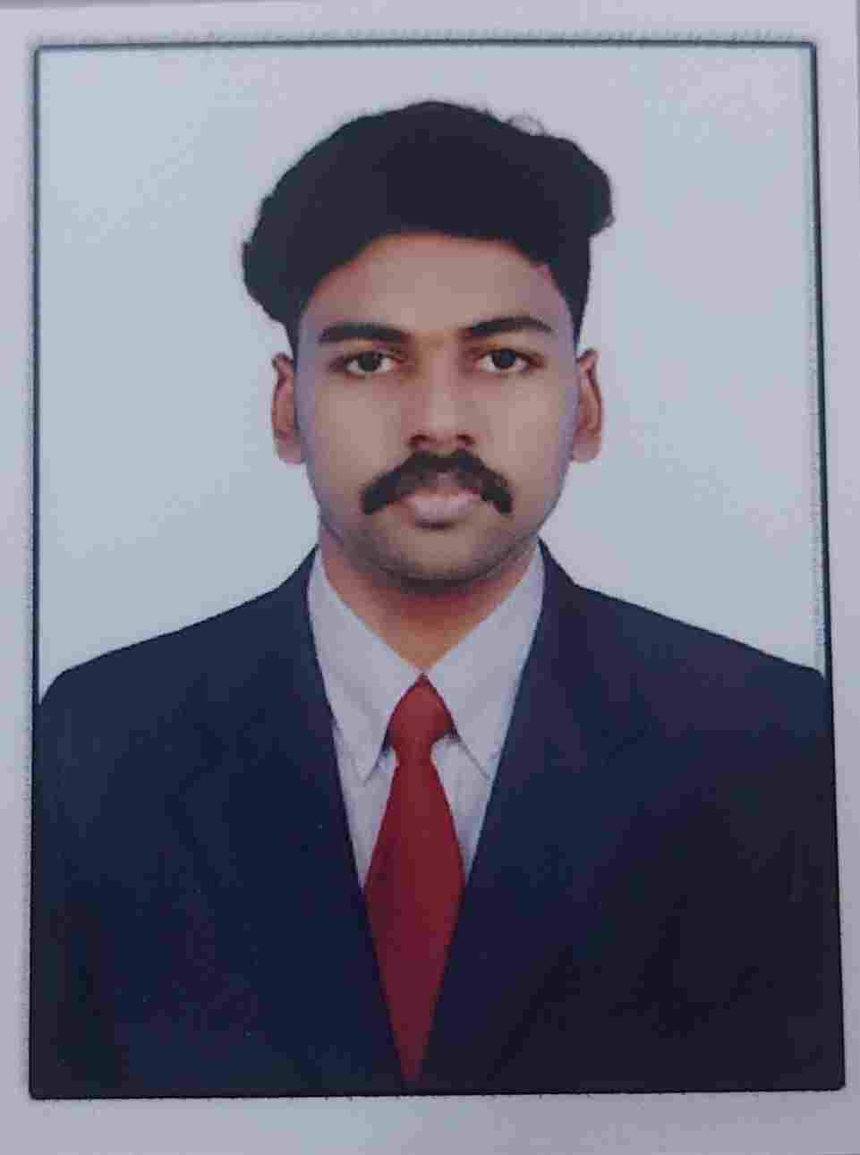
 | SAGADEVAN D  (613521104036) | 2021-25/CSE | GRADUATE ENGINEER  TRAINEE | SCHAEFFLER-INDIA  HOSUR | 2.2 LPA | 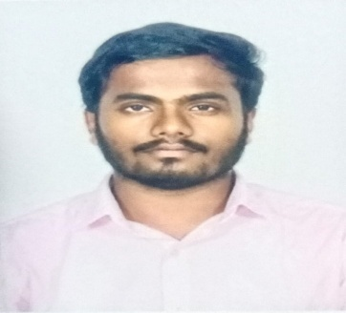
 | MOUNIKA T (613521104020) | 2021-25/CSE | GRADUATE ENGINEER  TRAINEE | SCHAEFFLER-INDIA  HOSUR | 2.2 LPA | 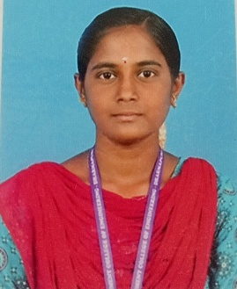
 | KEERTHANA G (613521104013) | 2021-25/CSE | GRADUATE ENGINEER TRAINEE | SCHAEFFLER-INDIA,HOSUR | 2.2 LPA | 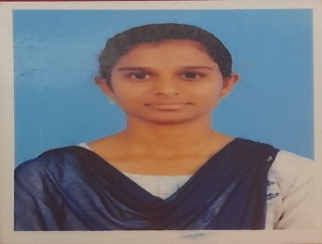
 | KEERTHANA G (613521104013) | 2021-25/CSE | XML Editor | Gold Win Tech | 2.2 LPA
 | MOULI RAJ S (613521104308) | 2021-25/CSE | GRADUATE ENGINEER  TRAINEE | SCHAEFFLER-INDIA  HOSUR | 2.2 LPA | 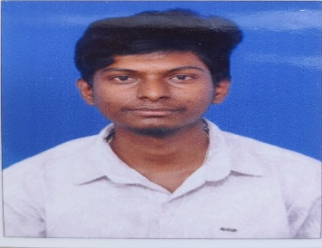
 | KUPPUSAMY V  (613521104015) | 2021-25/CSE | INSIDE SALES REPRESENTATIVE | GLOWLOGICS  SOLUTIONS  PVT LTD  BANGALORE | 4.2 LPA | 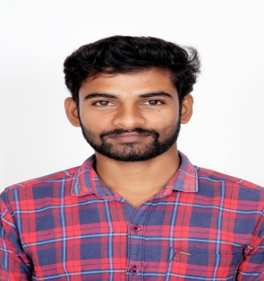
 | ARUN R  (613521104702) | 2021-25/CSE | BDA | SKILL INTERN PVT LTD  BANGALORE | 4.2 LPA | 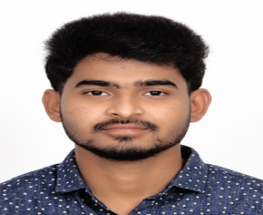
 | BHUVANESH M  (613521104303) | 2021-25/CSE | BDA | SKILL INTERN PVT LTD  BANGALORE | 4.2 LPA | 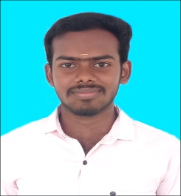
 | SUBASH R  (613521104046) | 2021-25/CSE | BDA | SKILL INTERN PVT LTD  BANGALORE | 4.2 LPA | 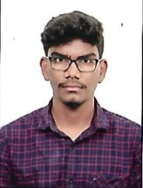
 | SARIGA S P  (613521104040) | 2021-25/CSE | BDA | SKILL INTERN PVT LTD  BANGALORE | 4.2 LPA | 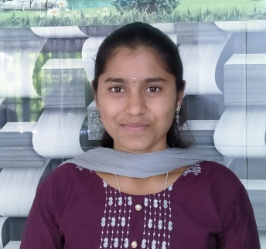
 | SARIGA S P  (613521104040) | 2021-25/CSE | INTERNSHIP | KNOD NEST | NIL
 | SARIGA S P  (613521104040) | 2021-25/CSE | INSIDE SALES REPRESENTATIVE | GLOWLOGICS  SOLUTIONS  PVT LTD  BANGALORE | 4.2 LPA
 | PRAVEEN KUMAR P  (613521104028) | 2021-25/CSE | BDA | SKILL INTERN PVT LTD  BANGALORE | 4.2 LPA | 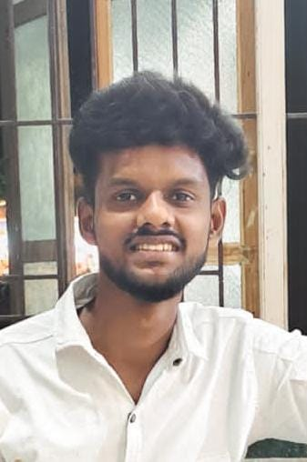
 | PRAVEEN KUMAR P  (613521104028) | 2021-25/CSE | INTERNSHIP | QSPIDERS  BANGALORE. | NIL
 | SATHYA SRI G  (613521104046) | 2021-25/CSE | GRADUATE ENGINEER  TRAINEE | SCHAEFFLER-INDIA  HOSUR | 2.2 LPA | 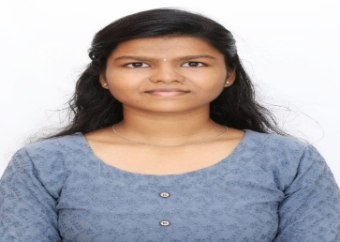
 | VISHNU V  (613521104048) | 2021-25/CSE | TRAINEE | KARYOUN INNOVATIONS | 4.5 LPA
 | KALIYAMOORTHY.T  (613521104013) | 2021-25/CSE | XML Editor | Gold Win Tech | 2.2 LPA
 | POOVIZHI.S  (613521104025) | 2021-25/CSE | XML Editor | Gold Win Tech | 2.2 LPA
 | SOWBARNIGA.P  (613521104045) | 2021-25/CSE | XML Editor | Gold Win Tech | 2.2 LPA
 | SANTHOSHKUMAR.S  (613521104045) | 2021-25/CSE | XML Editor | Gold Win Tech | 2.2 LPA
 | KUPPUSAMY.V  (613521104015) | 2021-25/CSE | INTRENSHIP | KNOD NEST | NIL
 | SATHIYASRI.G (613521104041) | 2021-25/CSE | INTRENSHIP | KNOD NEST | NIL

