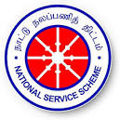 | GOVERNMENT COLLEGE OF ENGINEERING, DHARMAPURI-636 704.  NATIONAL SERVICE SCHEME ACTIVITY | 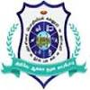

The National Service Scheme (NSS) organized an Awareness Programme on Cancer for the students of Government College of Engineering (GCE), Dharmapuri on 19.01.2026 and 20.01.2026. As part of this programme, the Heads of the Departments, faculty members, and students from various departments were visited and sensitized about cancer, its prevention, early detection, and the importance of adopting a healthy lifestyle. The programme aimed to create awareness and encourage active participation in promoting cancer prevention and health consciousness among the academic community.
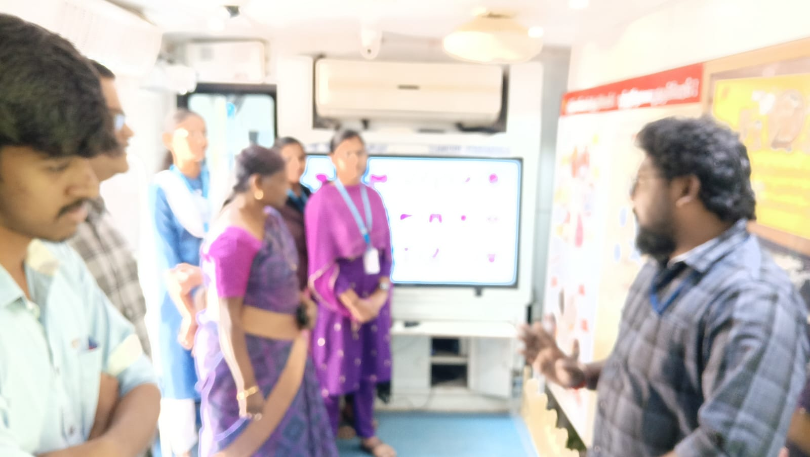
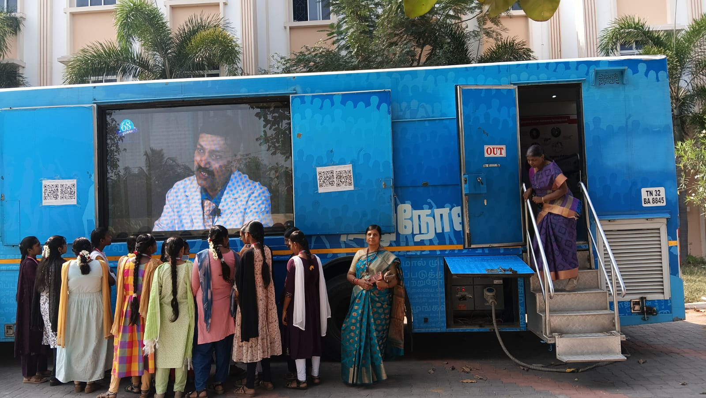 | 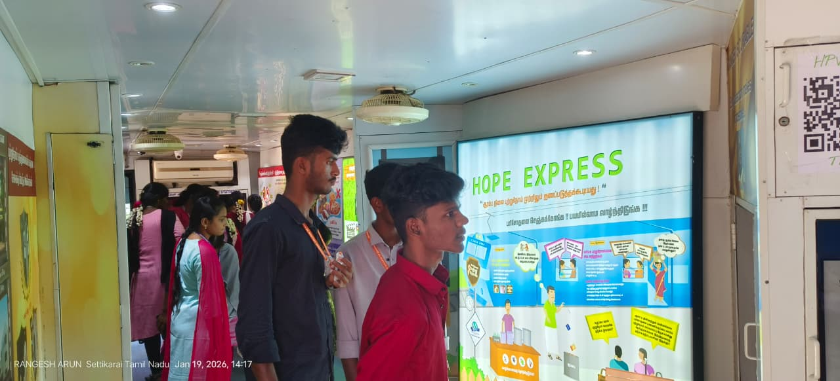
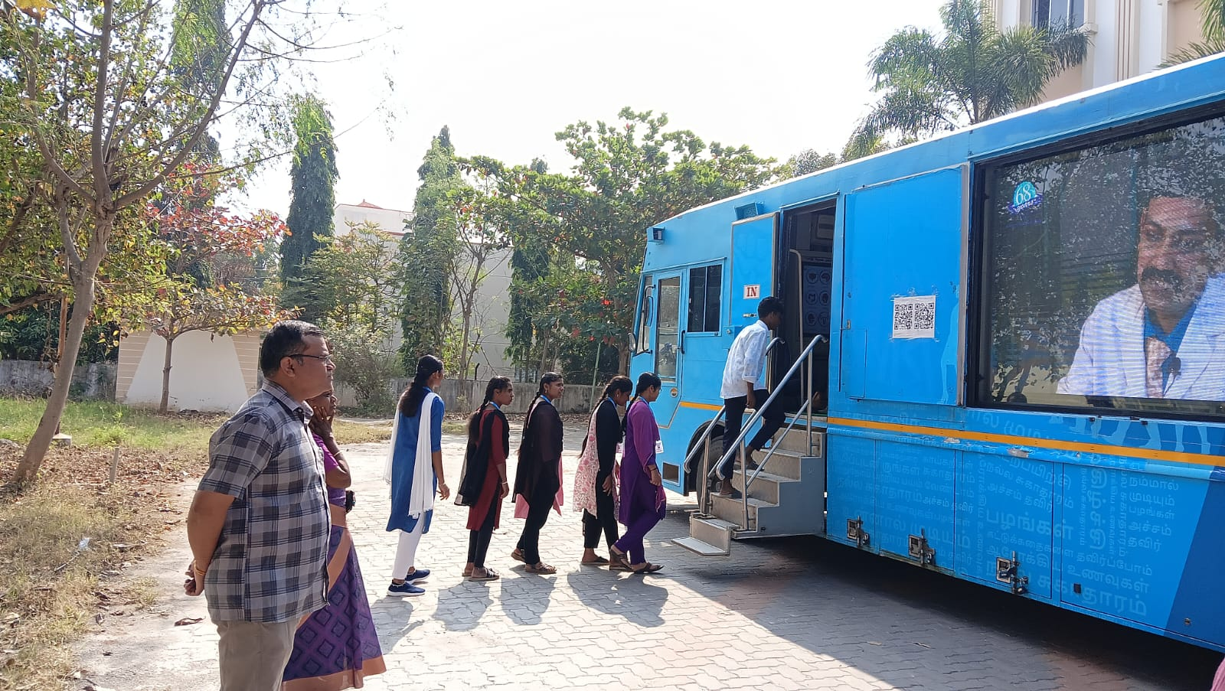 | 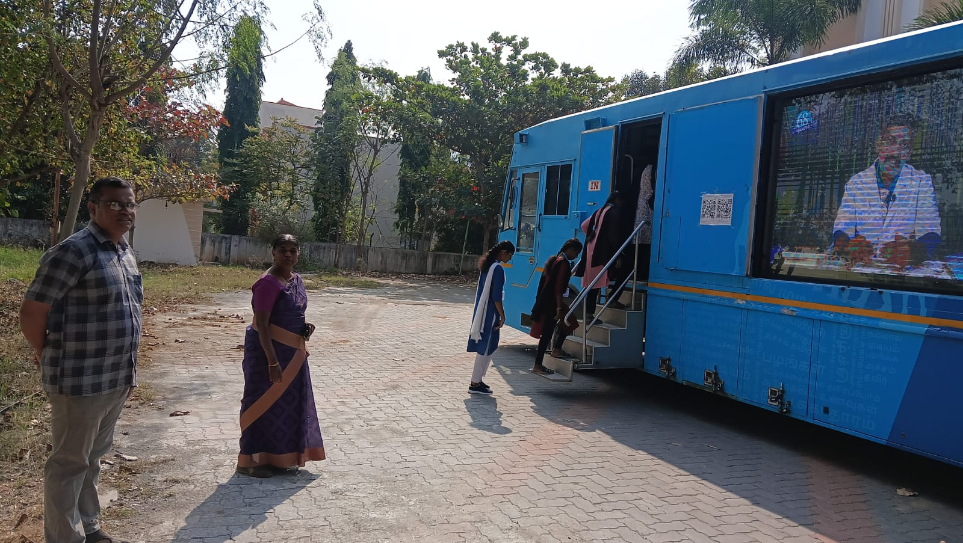

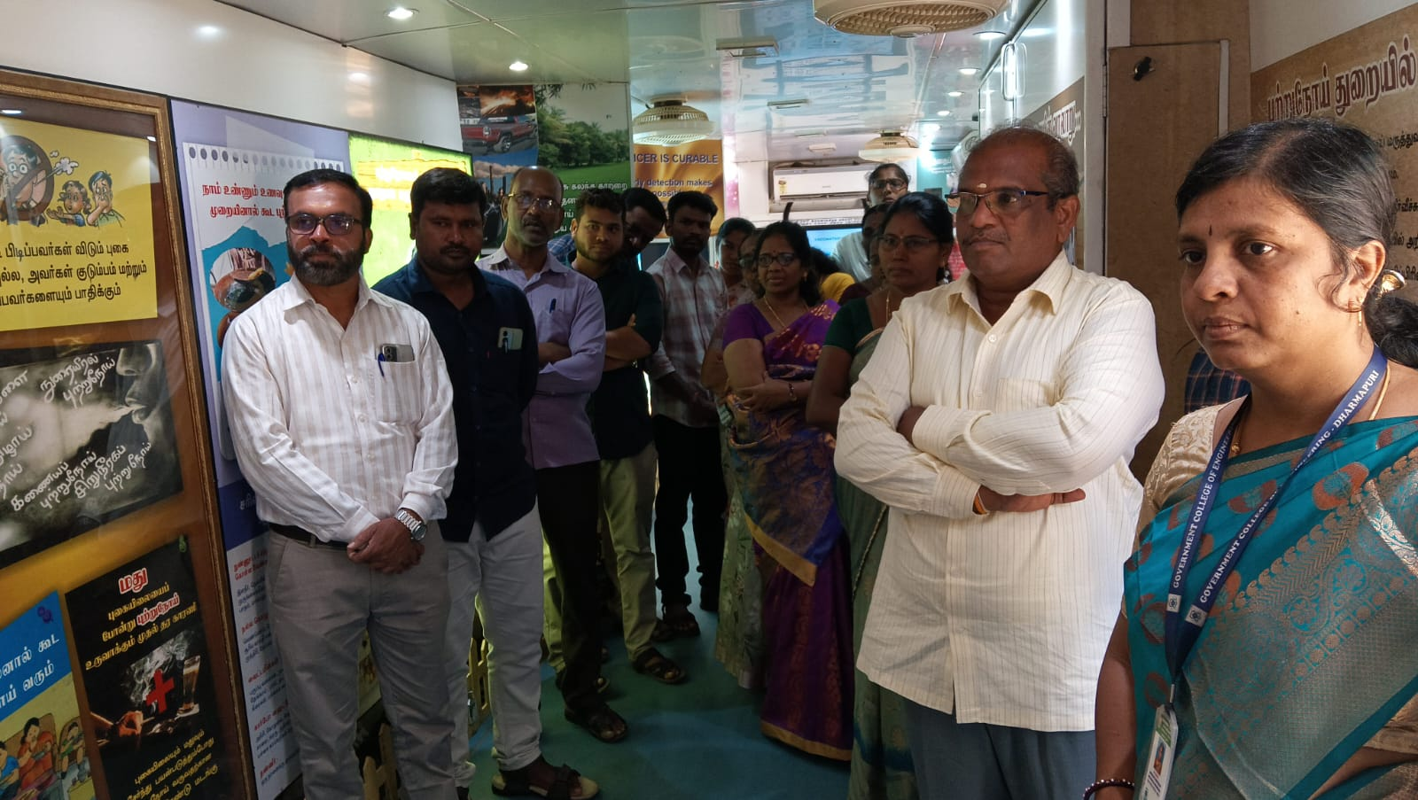 | 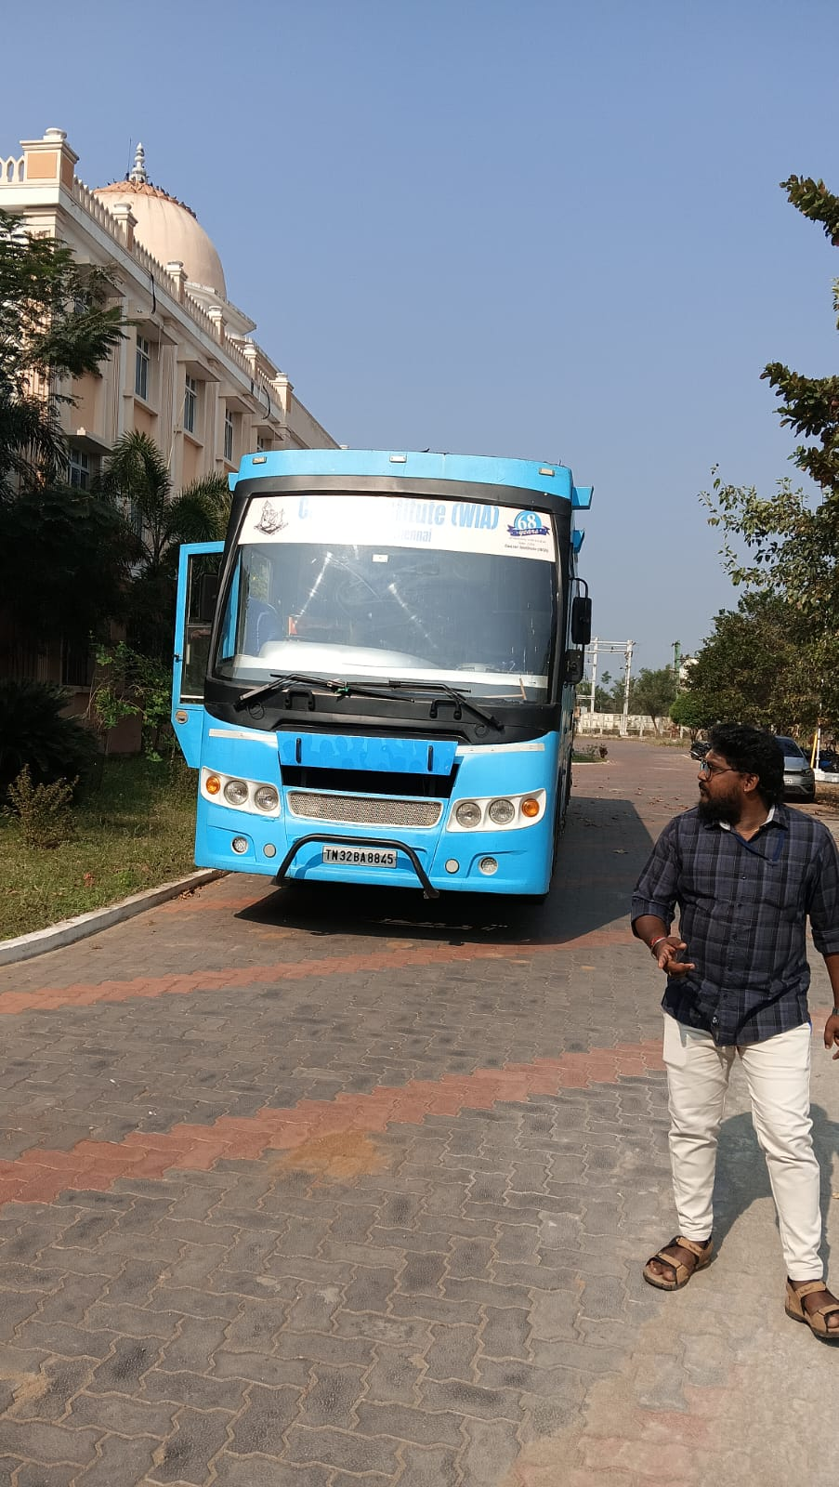
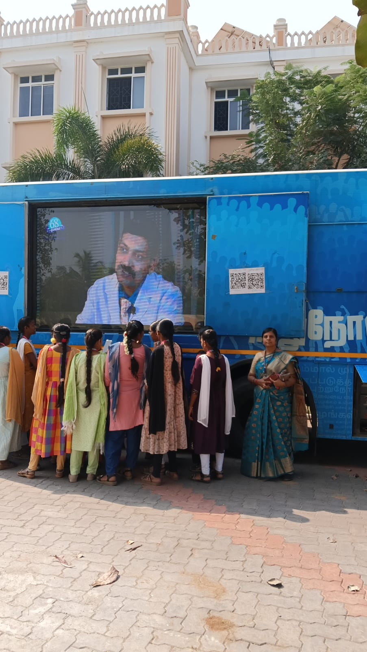 | 
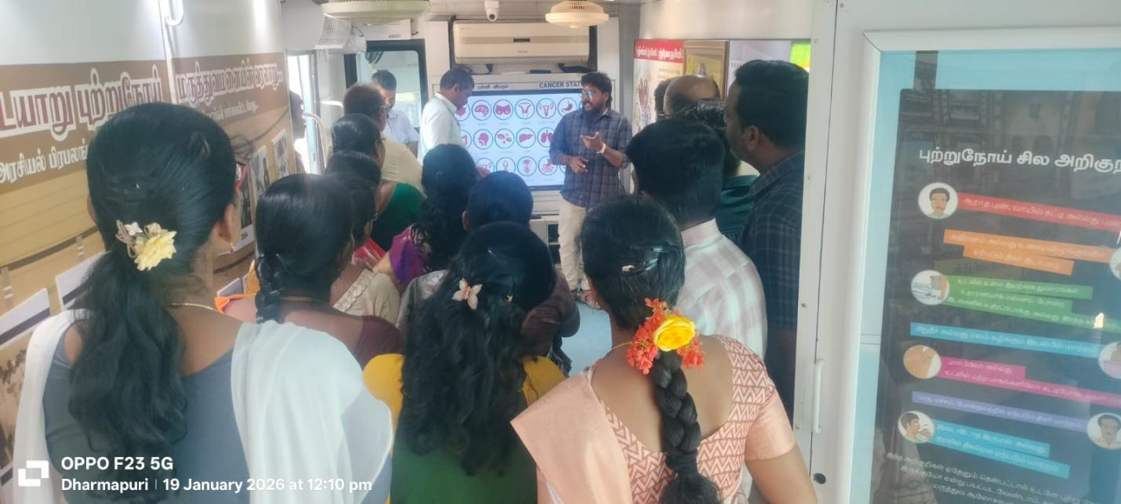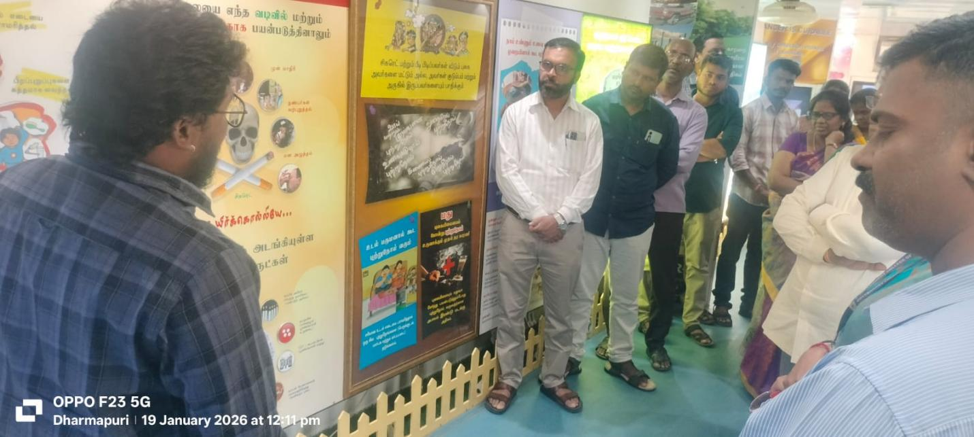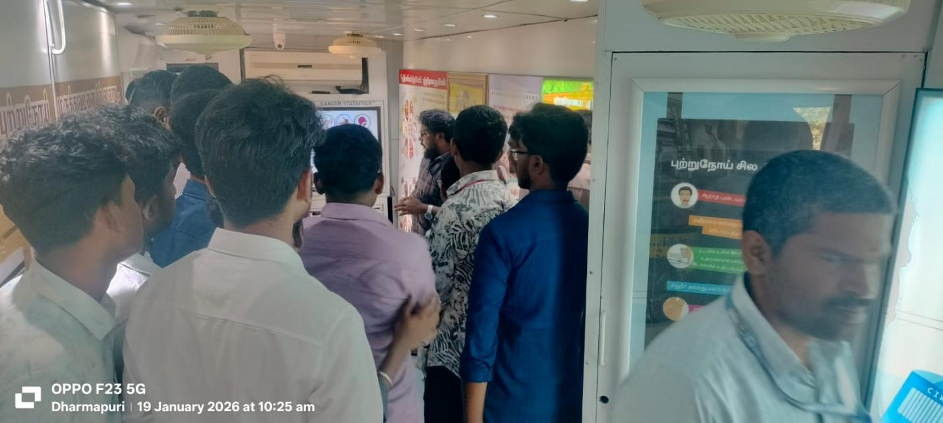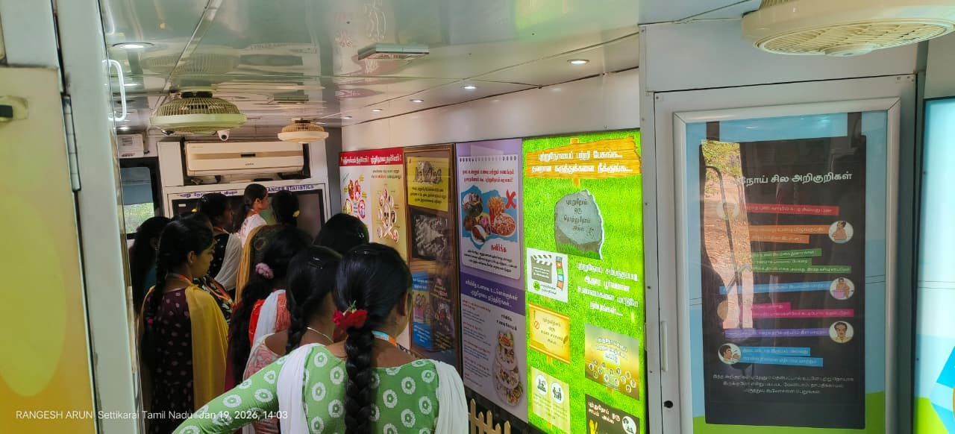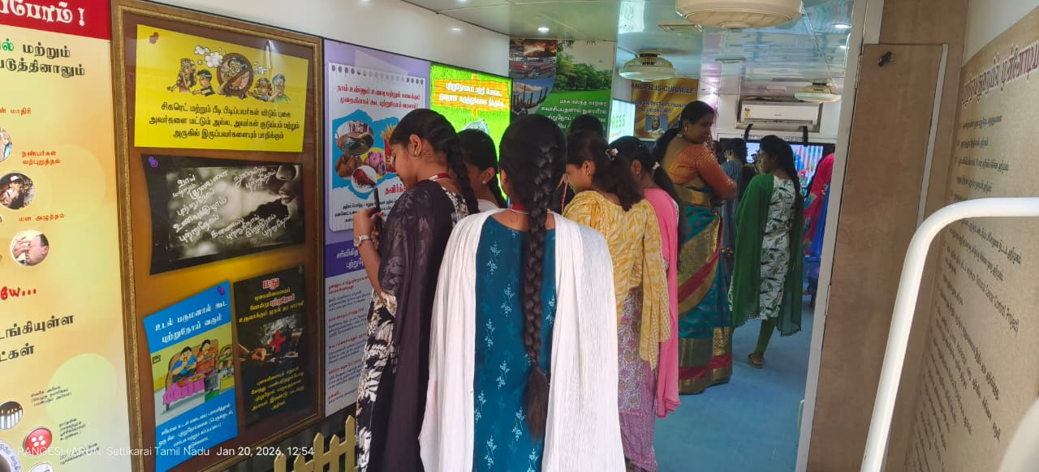
THANK YOU

