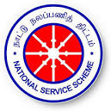 | GOVERNMENT COLLEGE OF ENGINEERING, DHARMAPURI-636 704. | 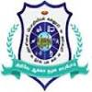

NATIONAL SERVICE SCHEME
The ban on single plastic video programme was conducted in seminar hall ,Govt college of engineering,dharmapuri on 19.09.2025. The video link were sent to remaining students through whats-app link.The videos are available in the link given below:-https://drive.google.com/drive/folders/1TWmsDIaj0un4gJNj64ieb1eaVlDdTvAy?usp=sharing
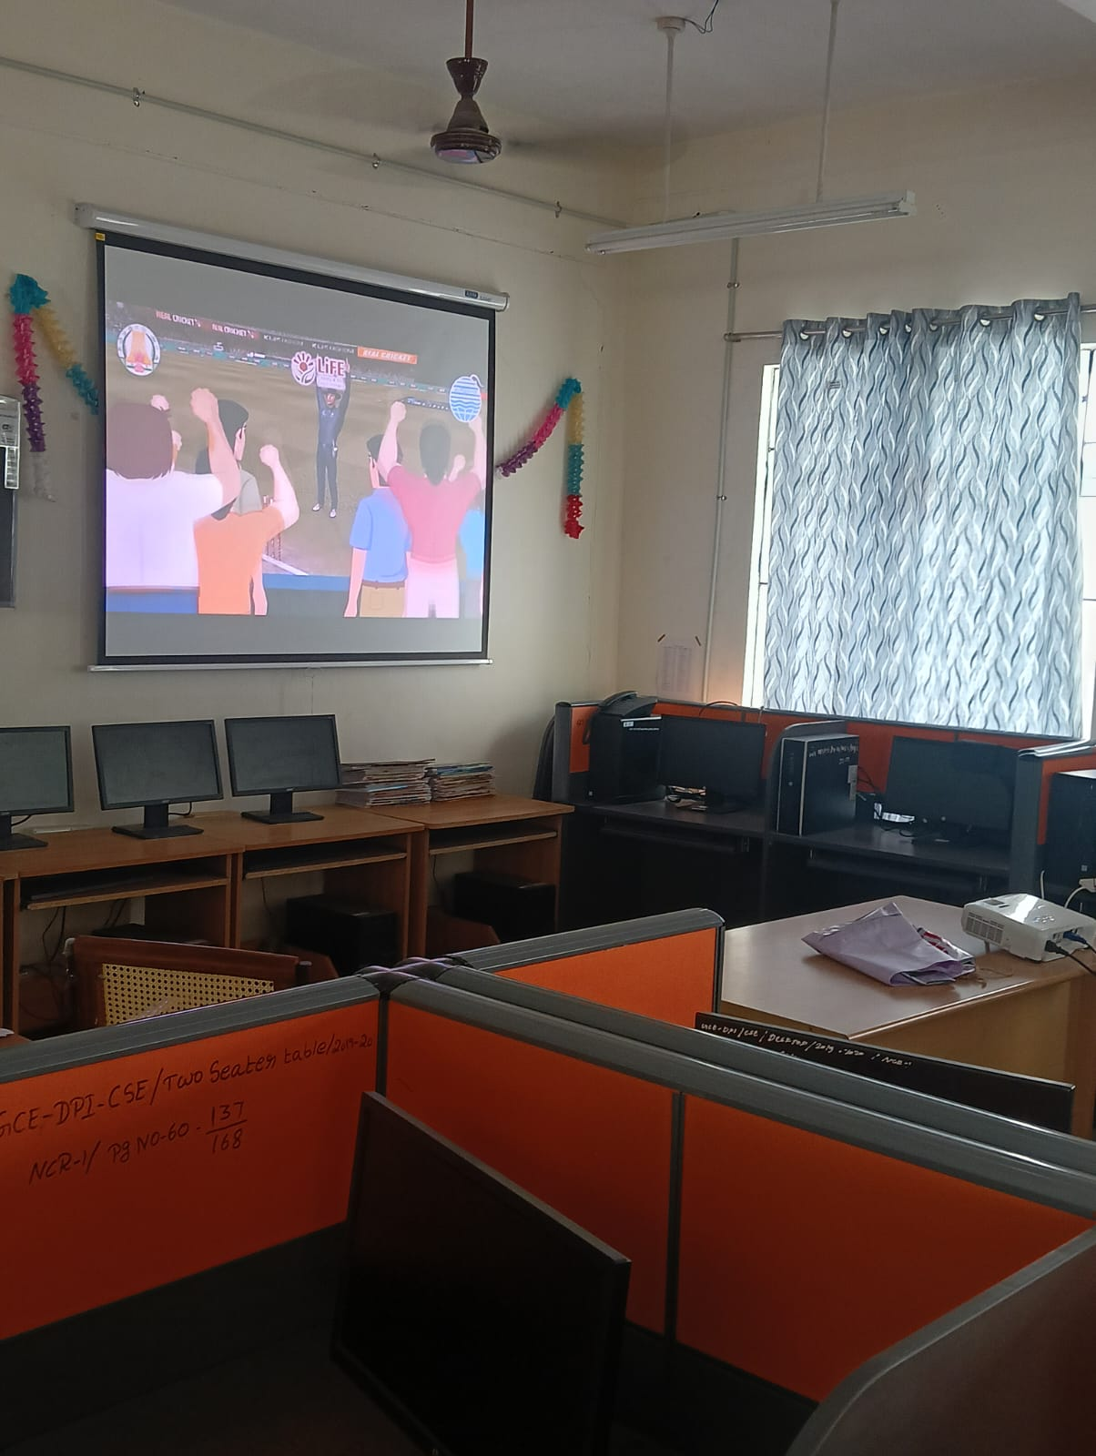 | 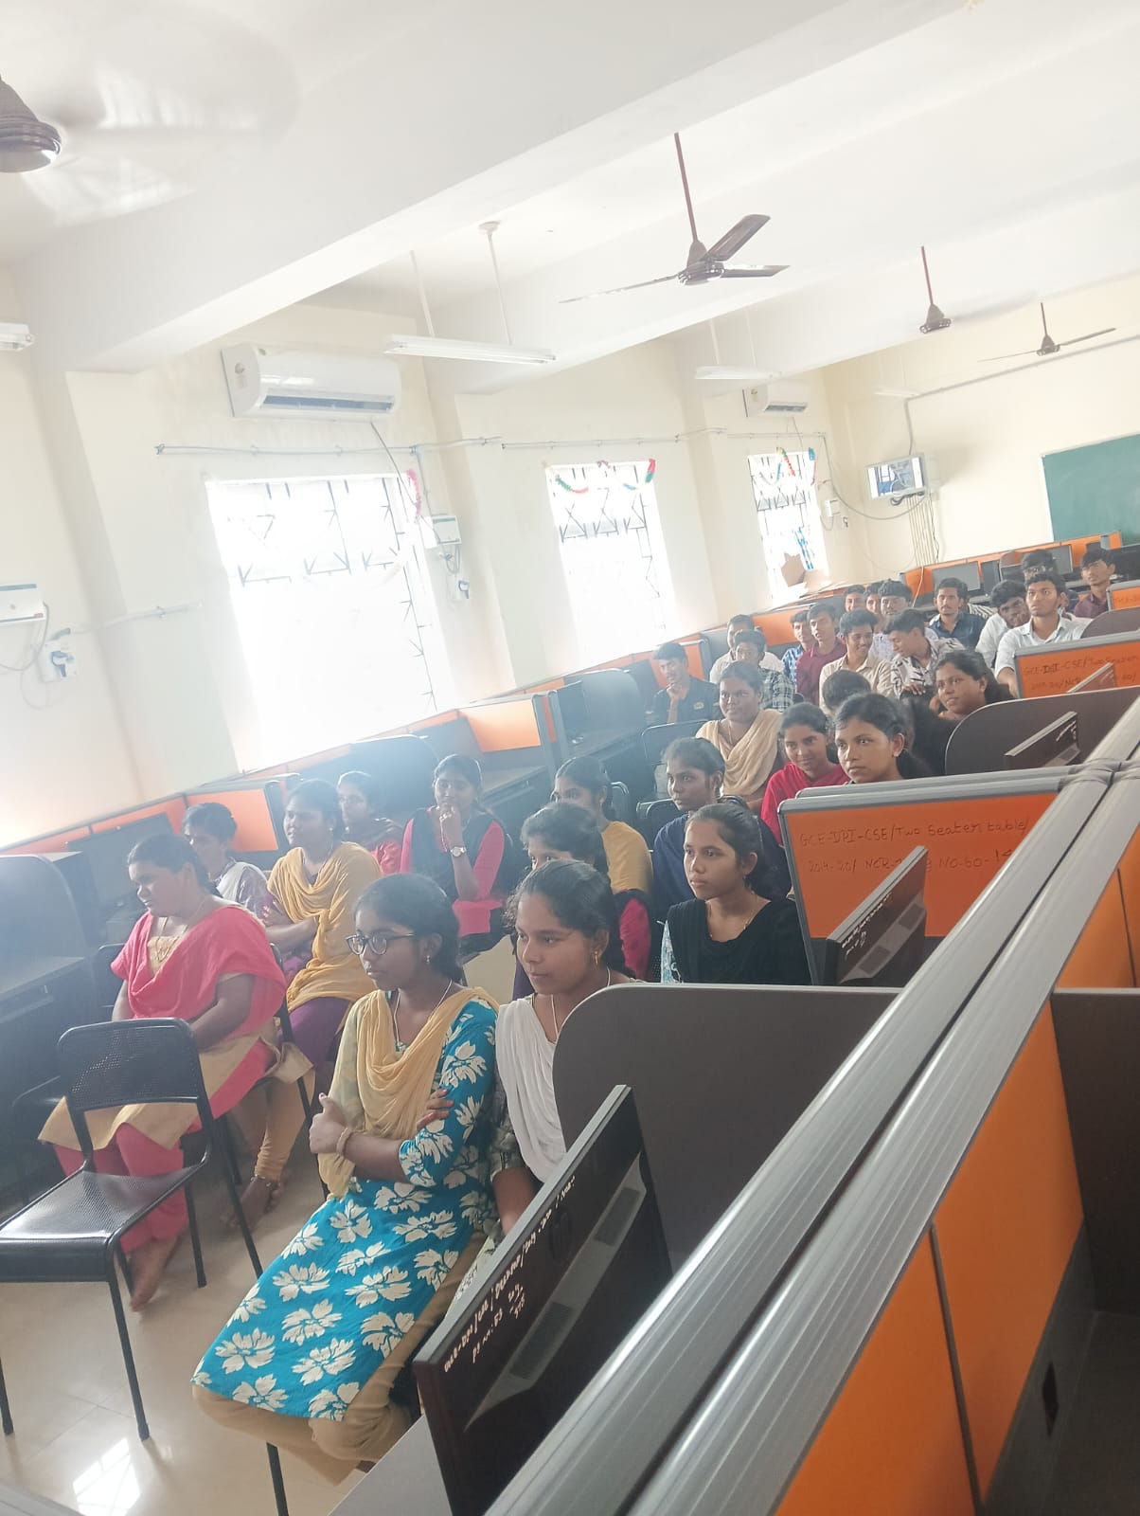
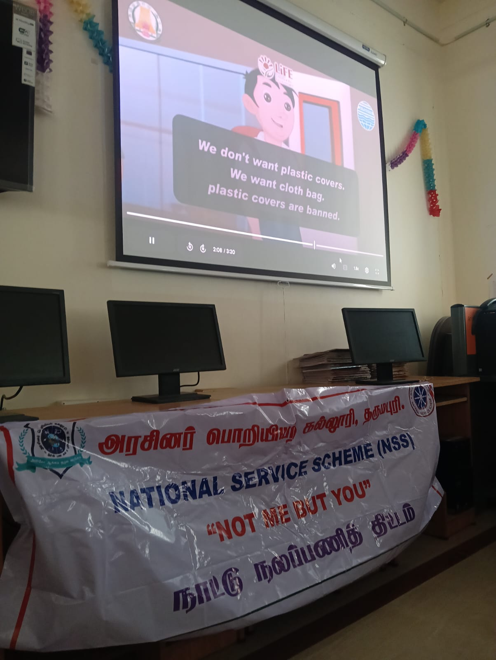 | 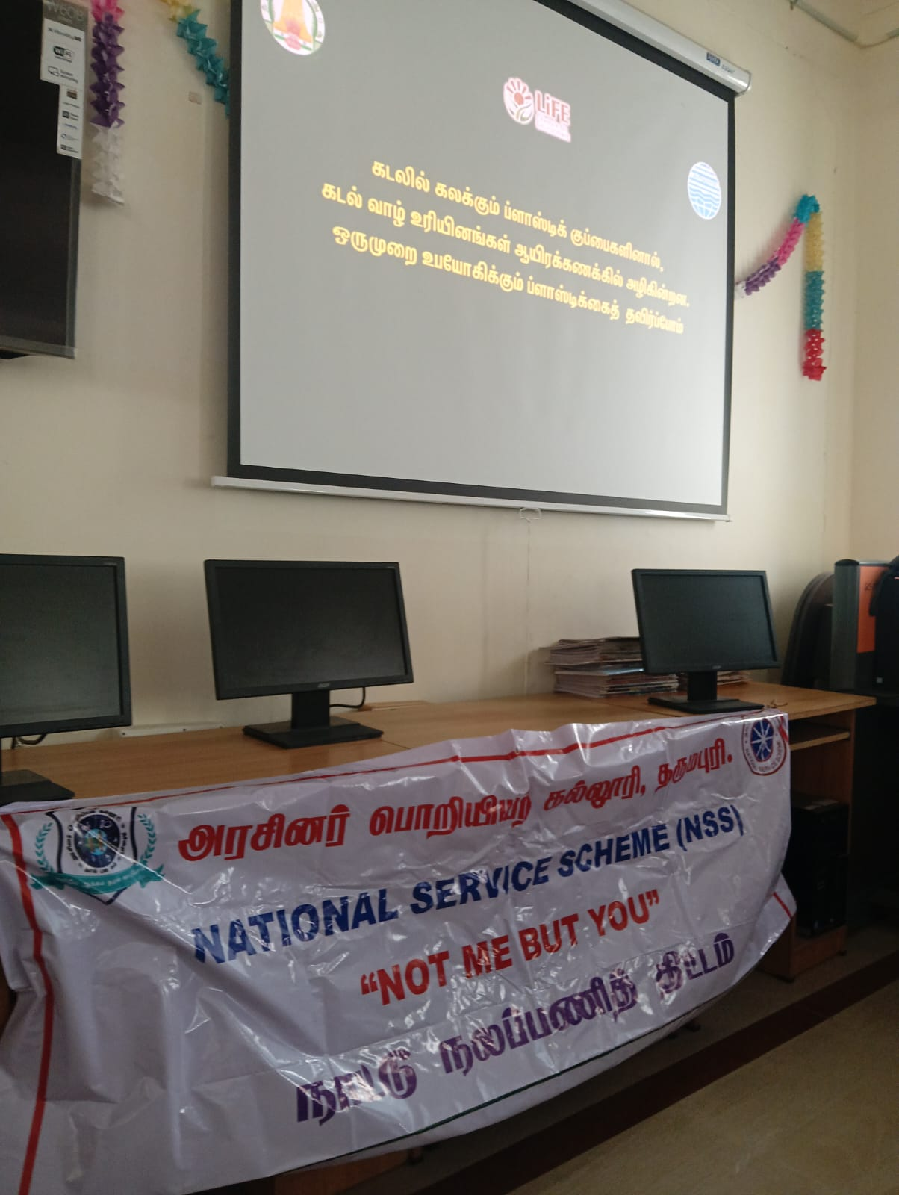

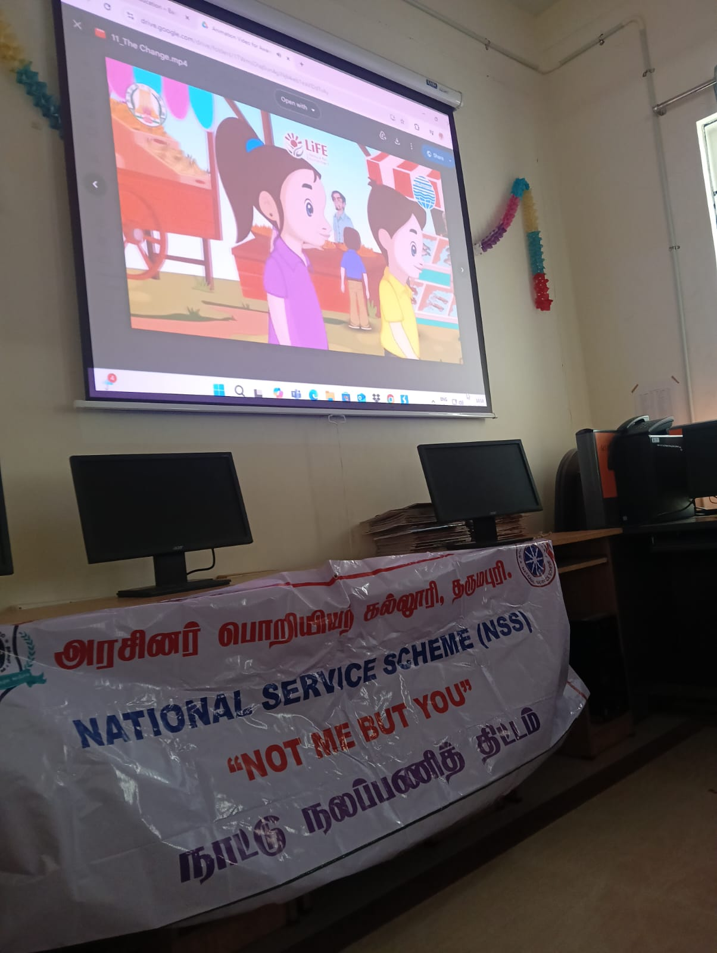 | 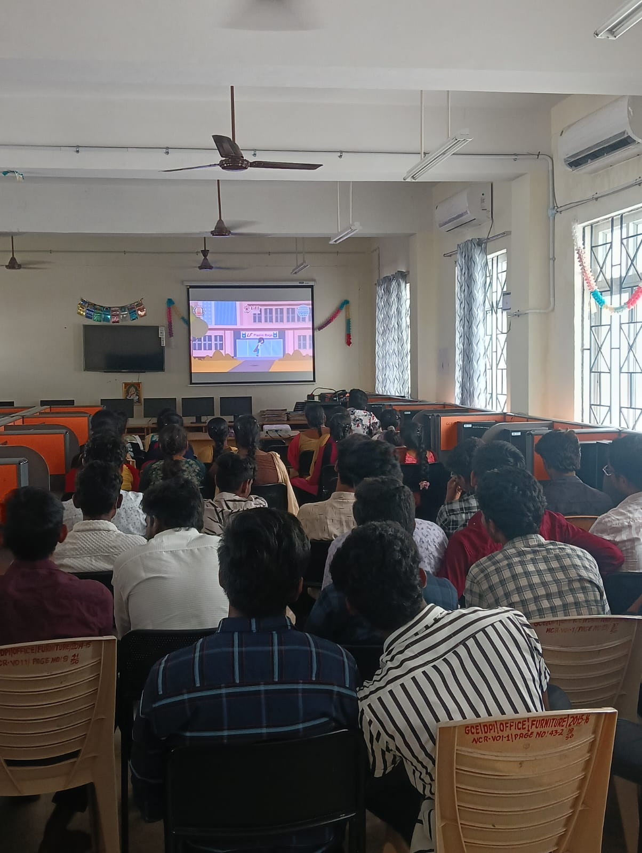
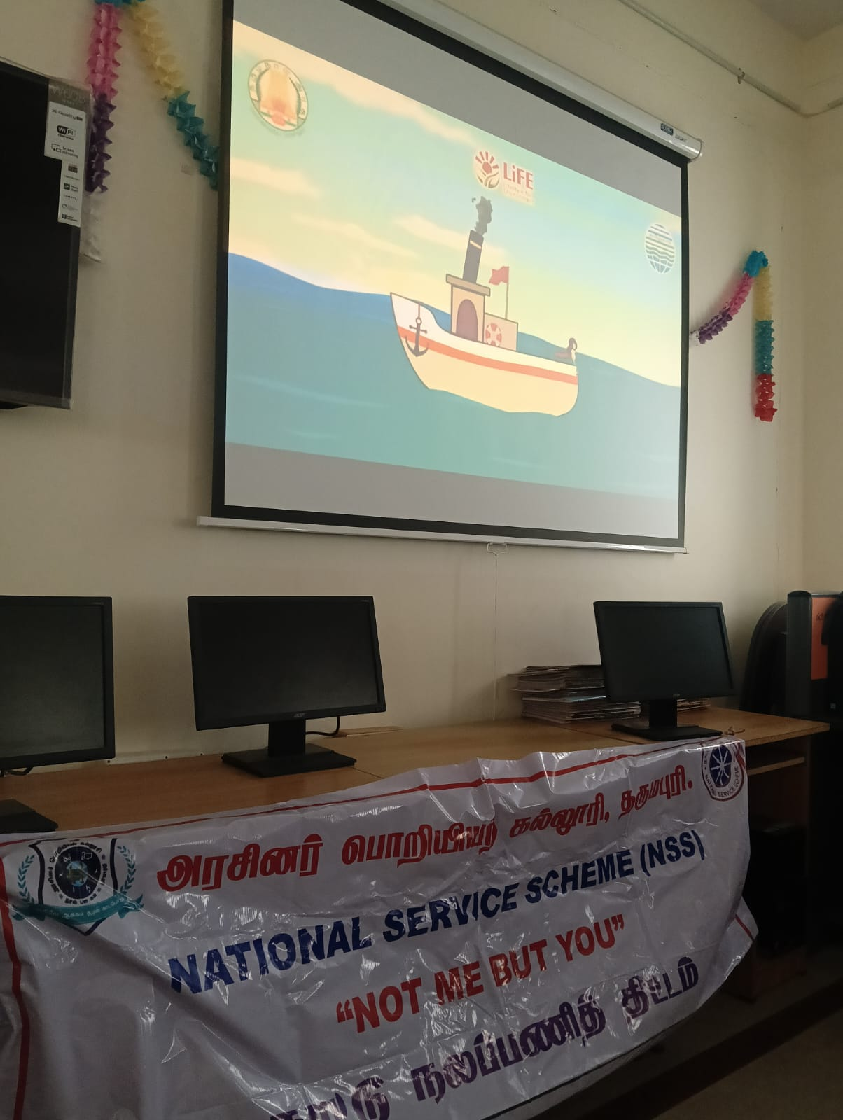 | 