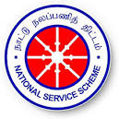 | GOVERNMENT COLLEGE OF ENGINEERING, DHARMAPURI-636 704.  NATIONAL SERVICE SCHEME | 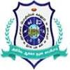
NO HELMET NO ENTRY BOARD INSTALLATION AND PROGRAMME @ GCE, Dharmapuri – 20th Feb, 2026
The “No Helmet – No Entry” board installation and awareness programme was conducted at Government College of Engineering, Dharmapuri on 20th February 2026 with the objective of promoting road safety and responsible riding habits among students and staff. As part of the programme, prominent signboards carrying the message “No Helmet – No Entry” were installed at the campus entrance and key locations to strictly enforce helmet usage for two-wheeler riders. The initiative emphasized the importance of wearing helmets to prevent head injuries and reduce road accident fatalities. Faculty members, students, and supporting staff actively participated in the programme, reinforcing the institution’s commitment to safety, discipline, and social responsibility. The programme created awareness and encouraged a culture of safe commuting within and around the campus.
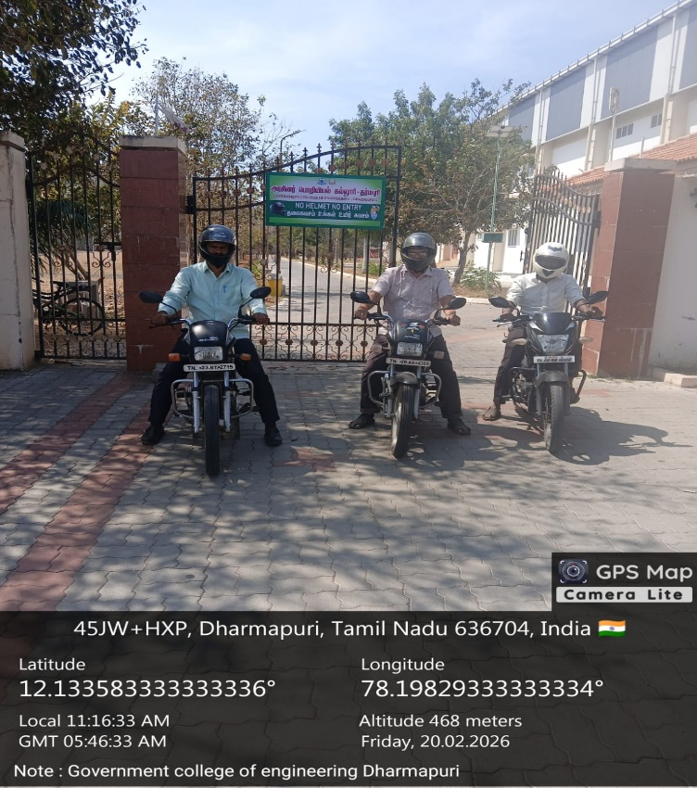 | 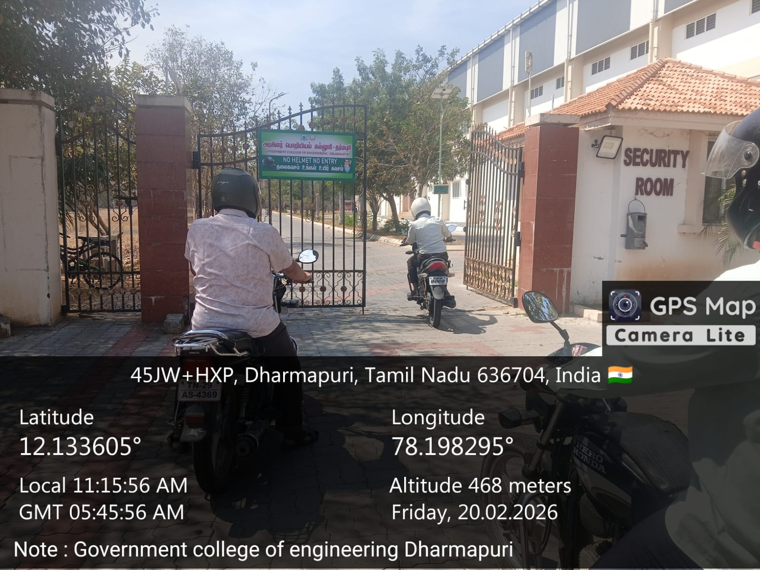
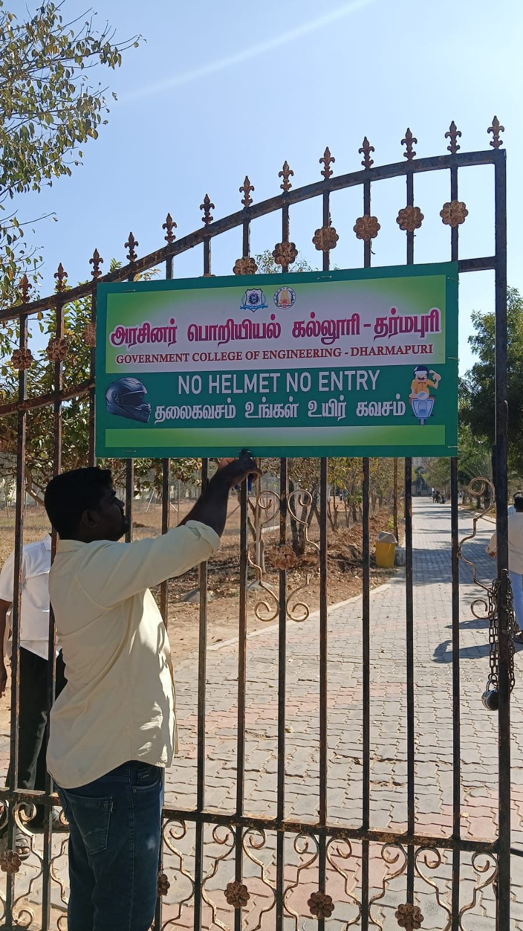 | 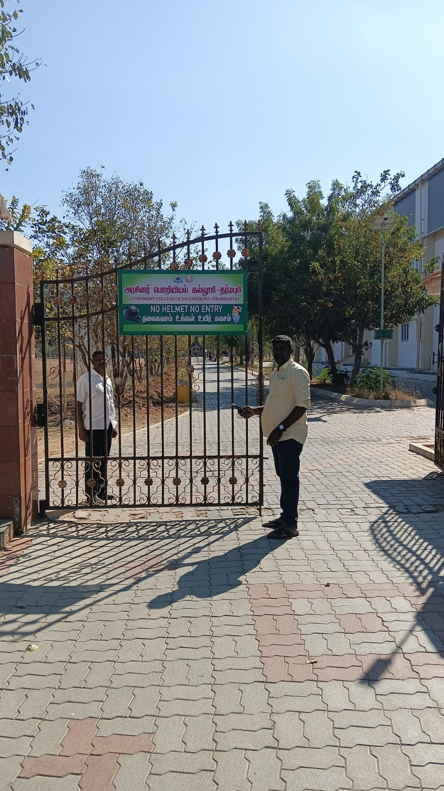
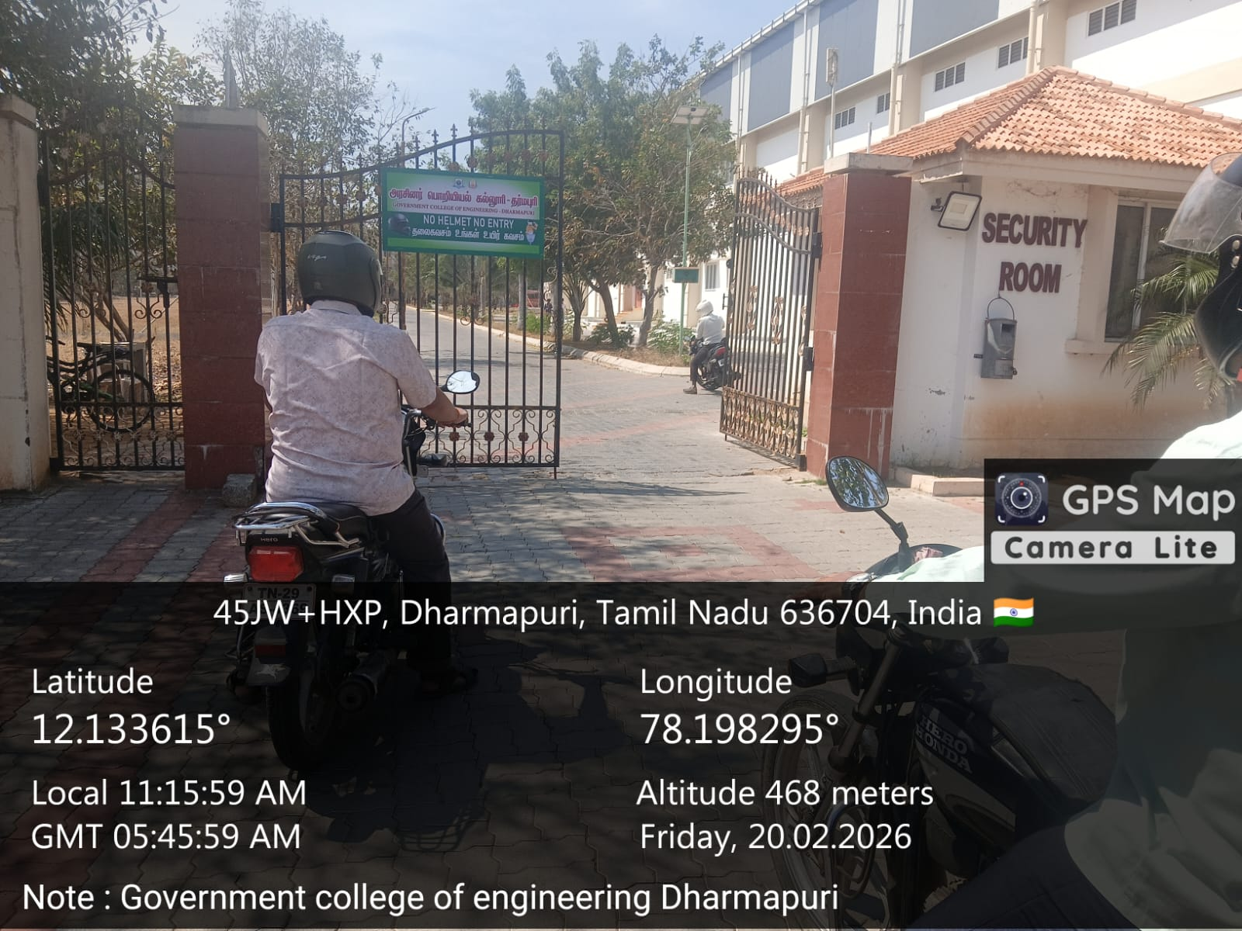 | 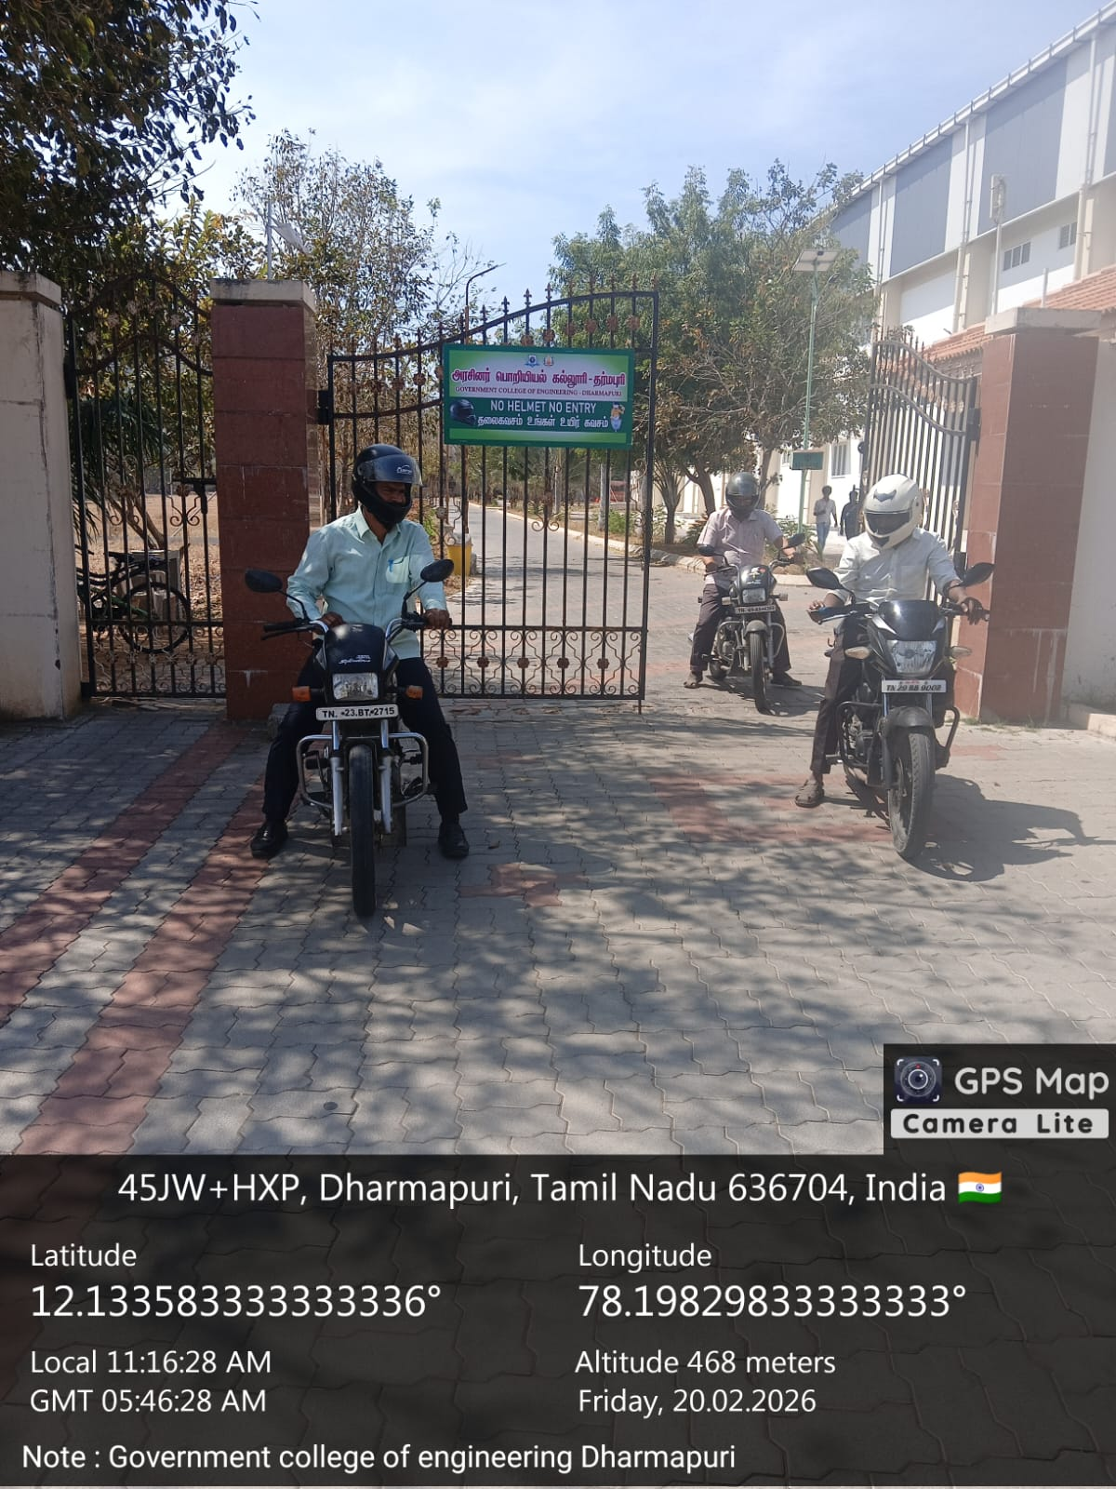

Thank You

