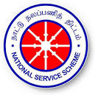 | GOVERNMENT COLLEGE OF ENGINEERING, DHARMAPURI-636 704.  NATIONAL SERVICE SCHEME | 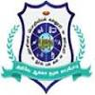
Exposure Visit @ GCE, Dharmapuri – 17th February ,2026
Students of GTR HSS Naripalli School visited the Government College of Engineering, Dharmapuri campus on 17th February 2026 as part of an Exposure Visit. During the visit, the students explored various laboratories, workshops, academic departments, and campus facilities. The programme provided valuable insights into engineering education, practical applications, and institutional infrastructure, helping students gain first-hand exposure to higher technical learning environments and career opportunities in engineering.
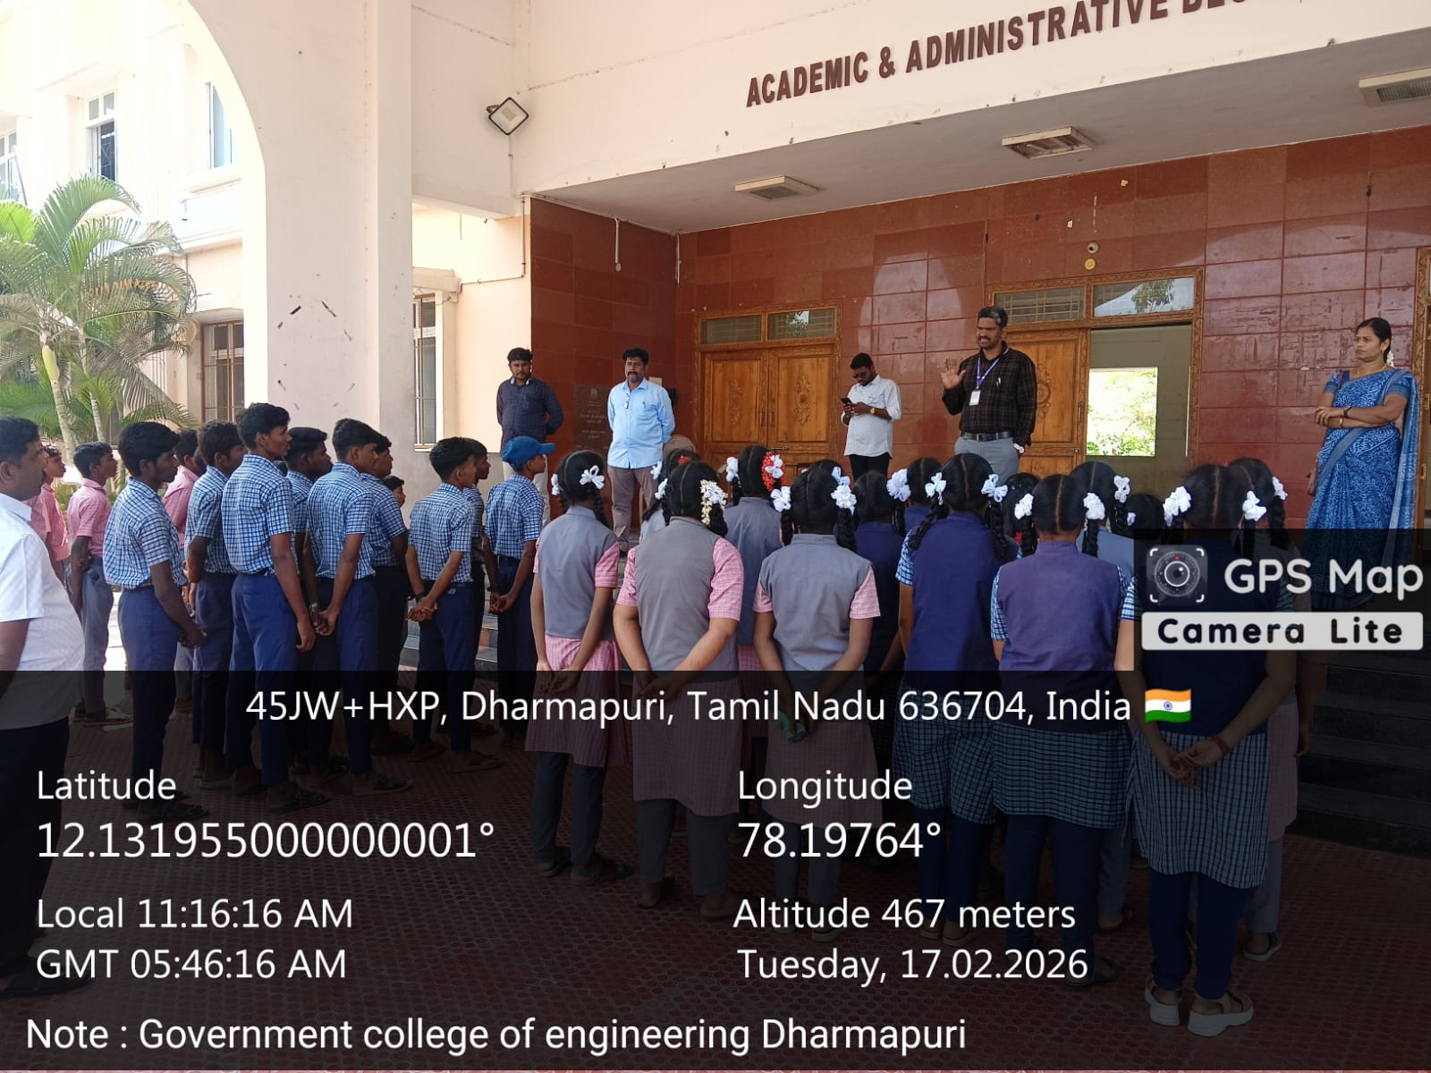 | 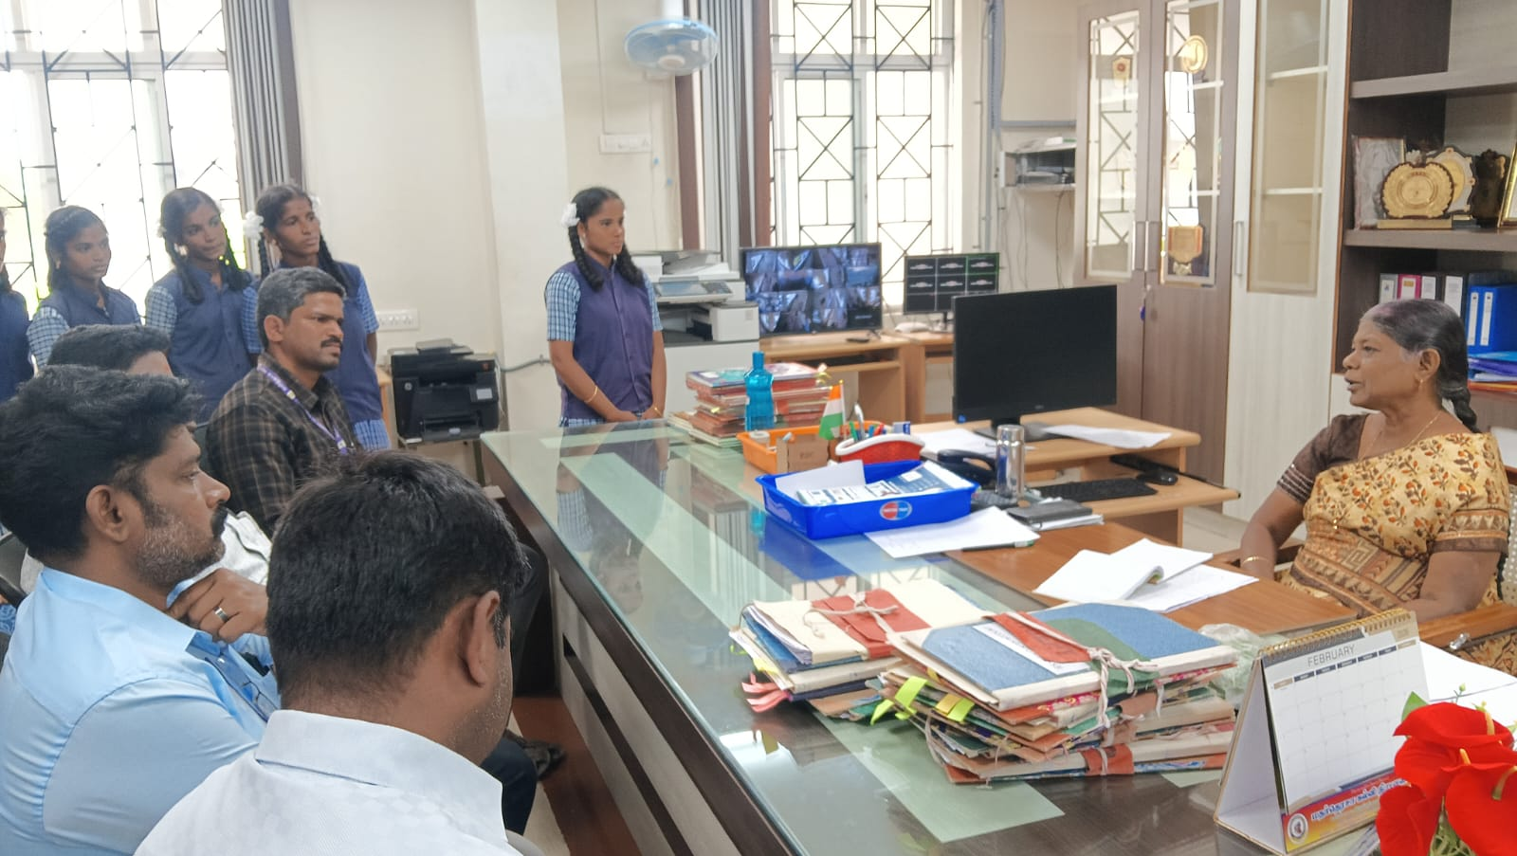
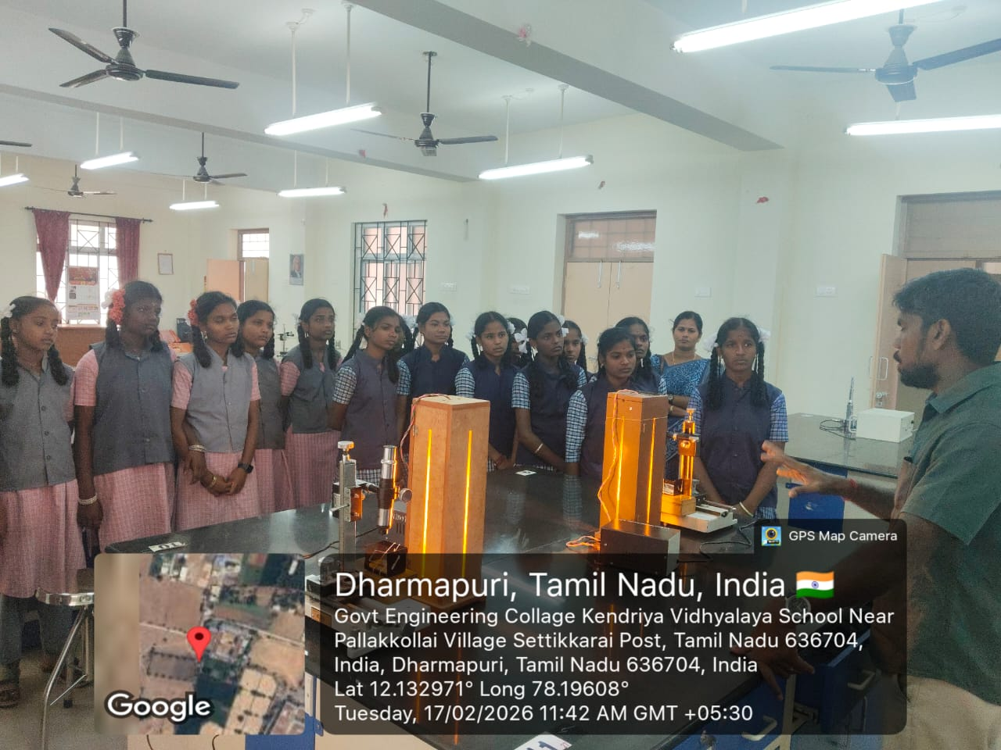 | 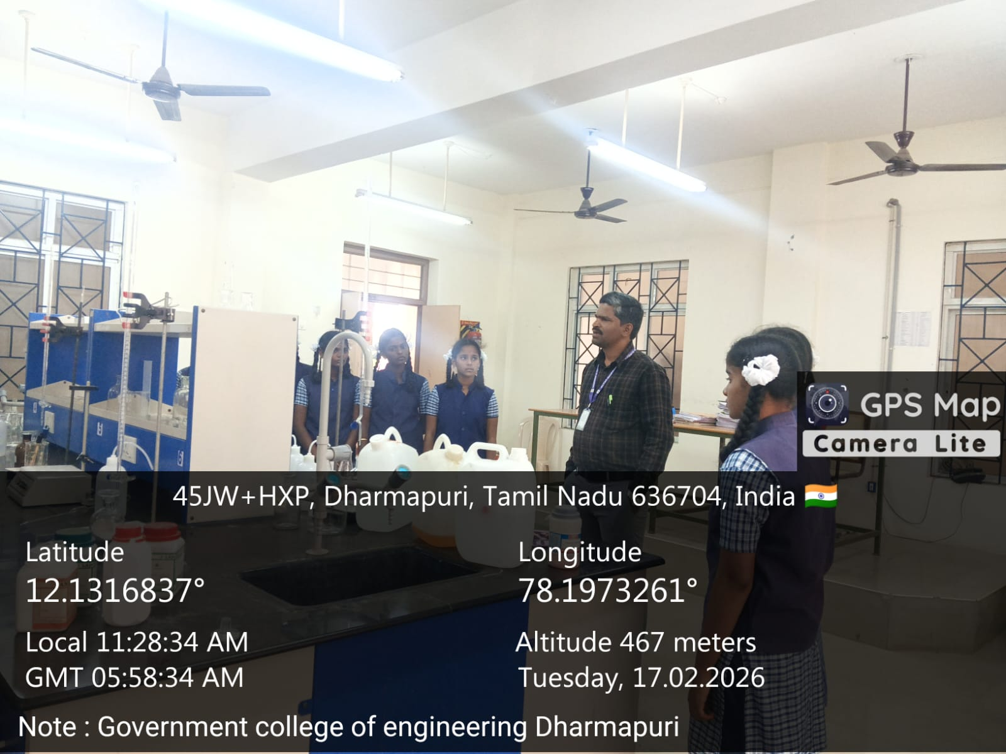

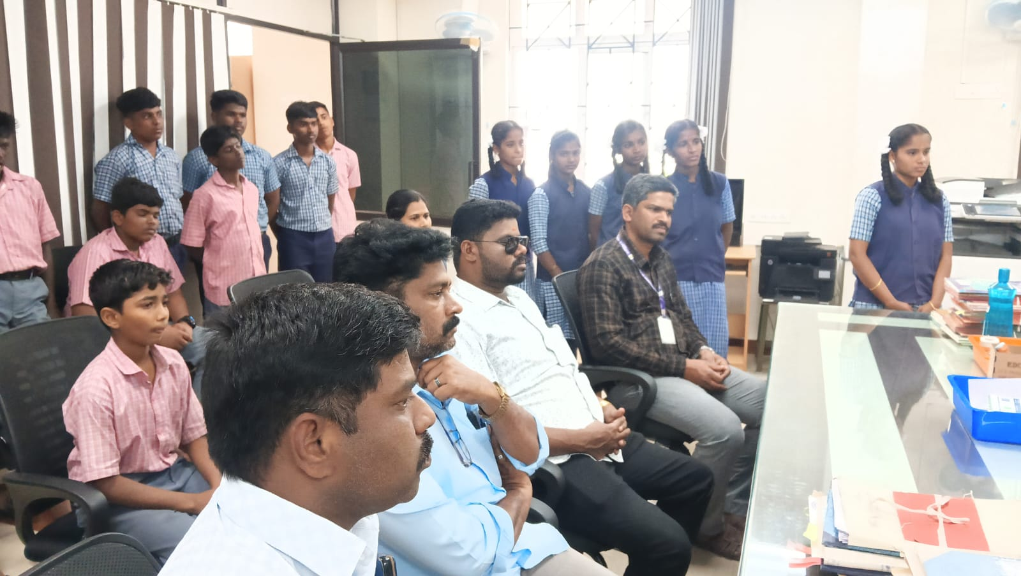 | 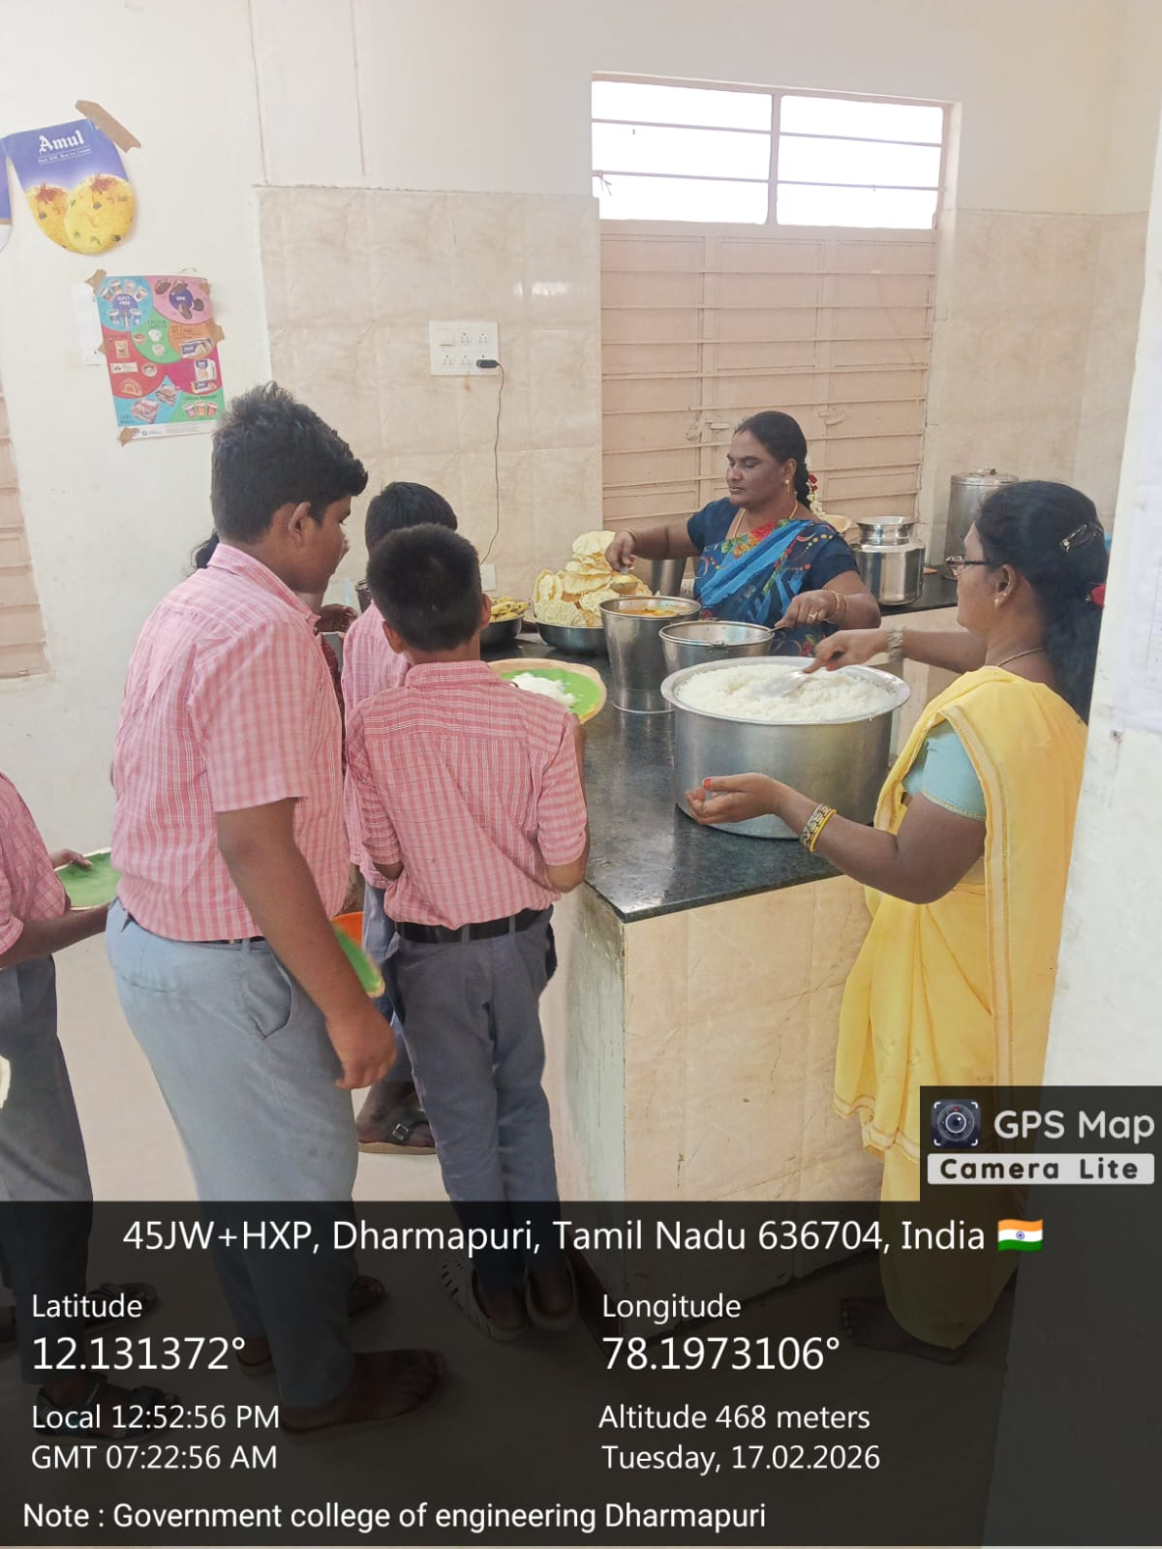
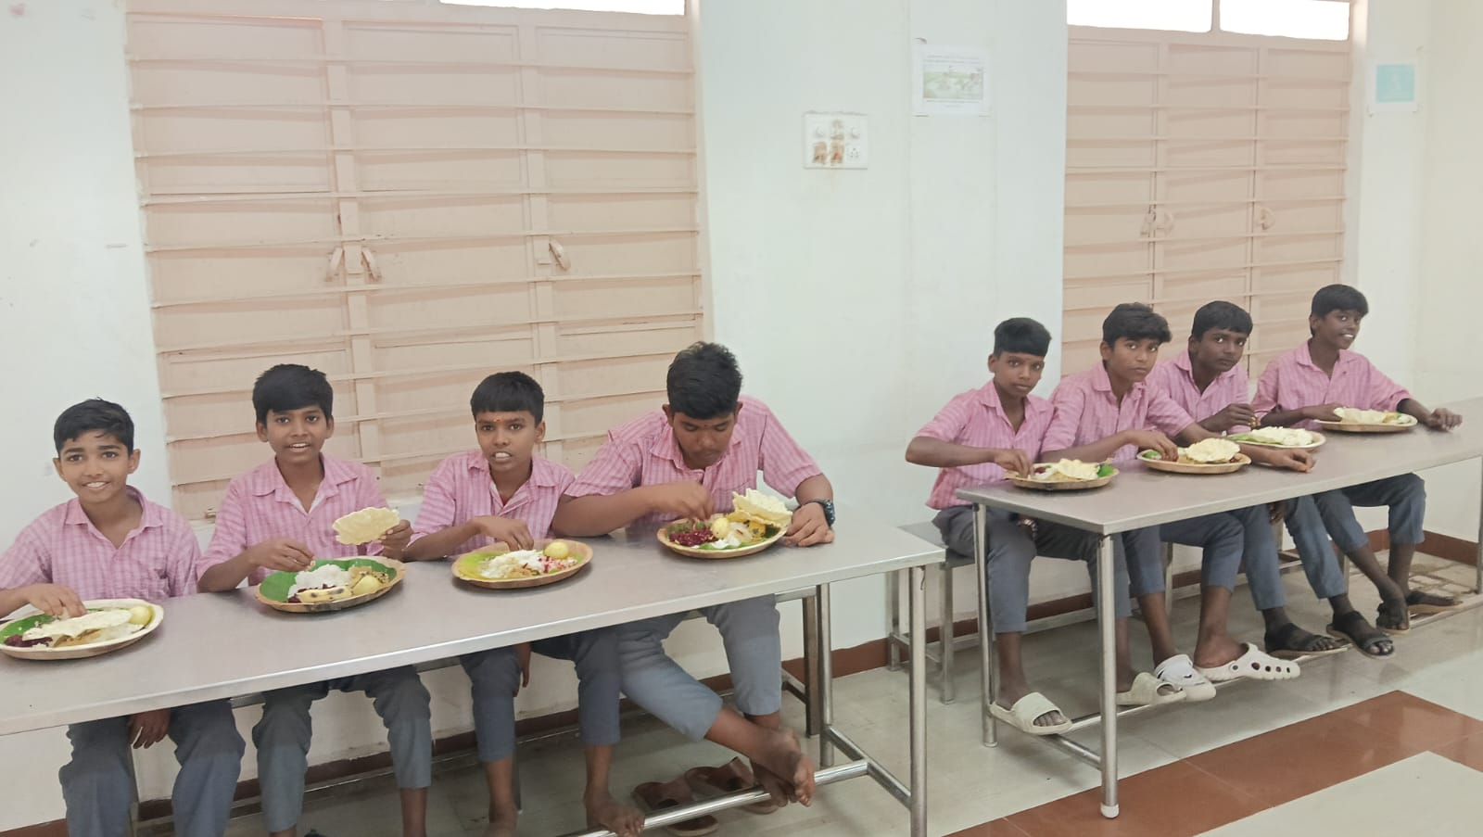 | 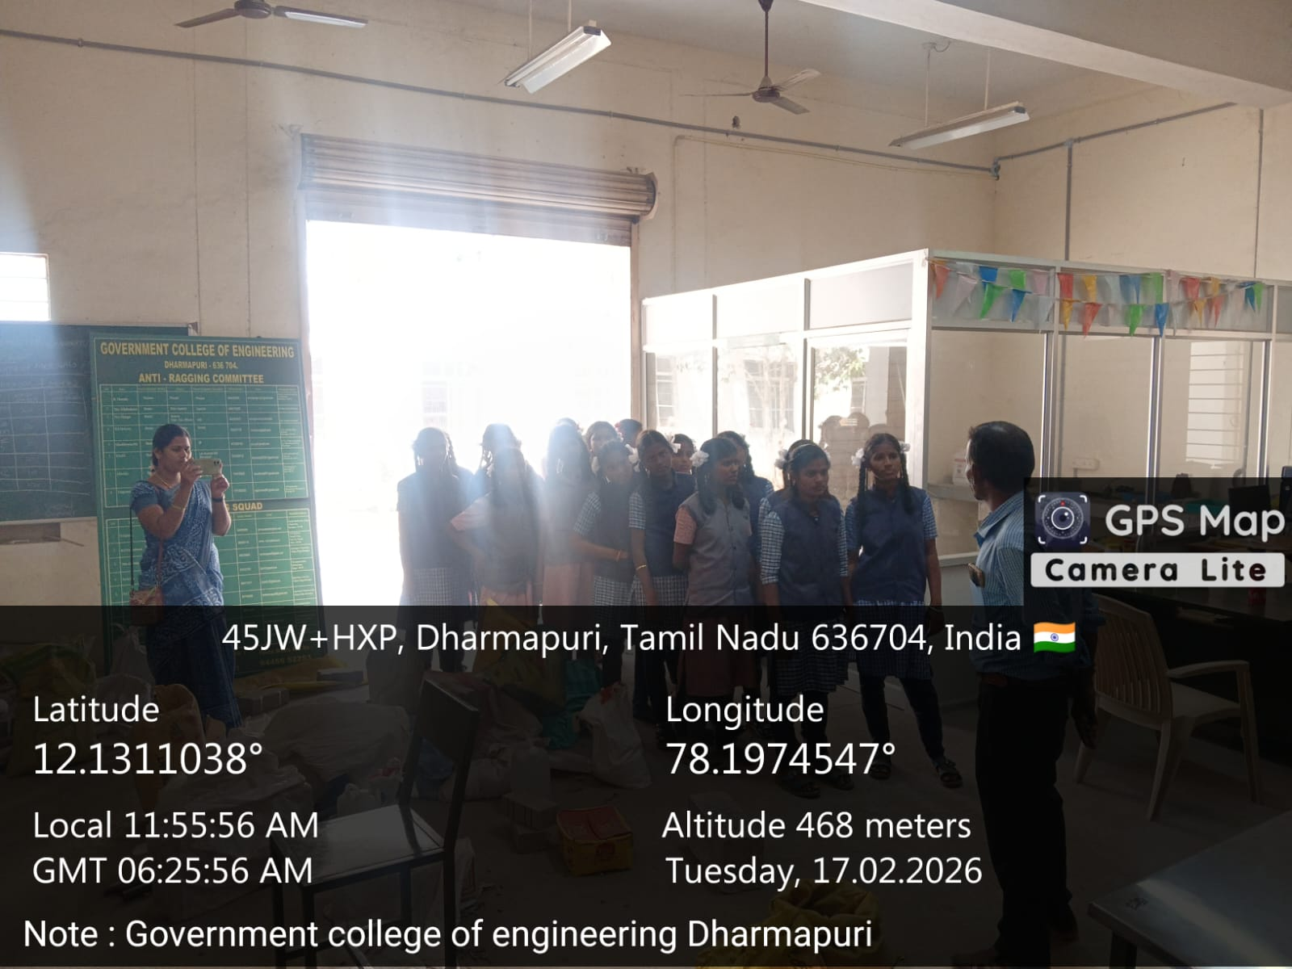

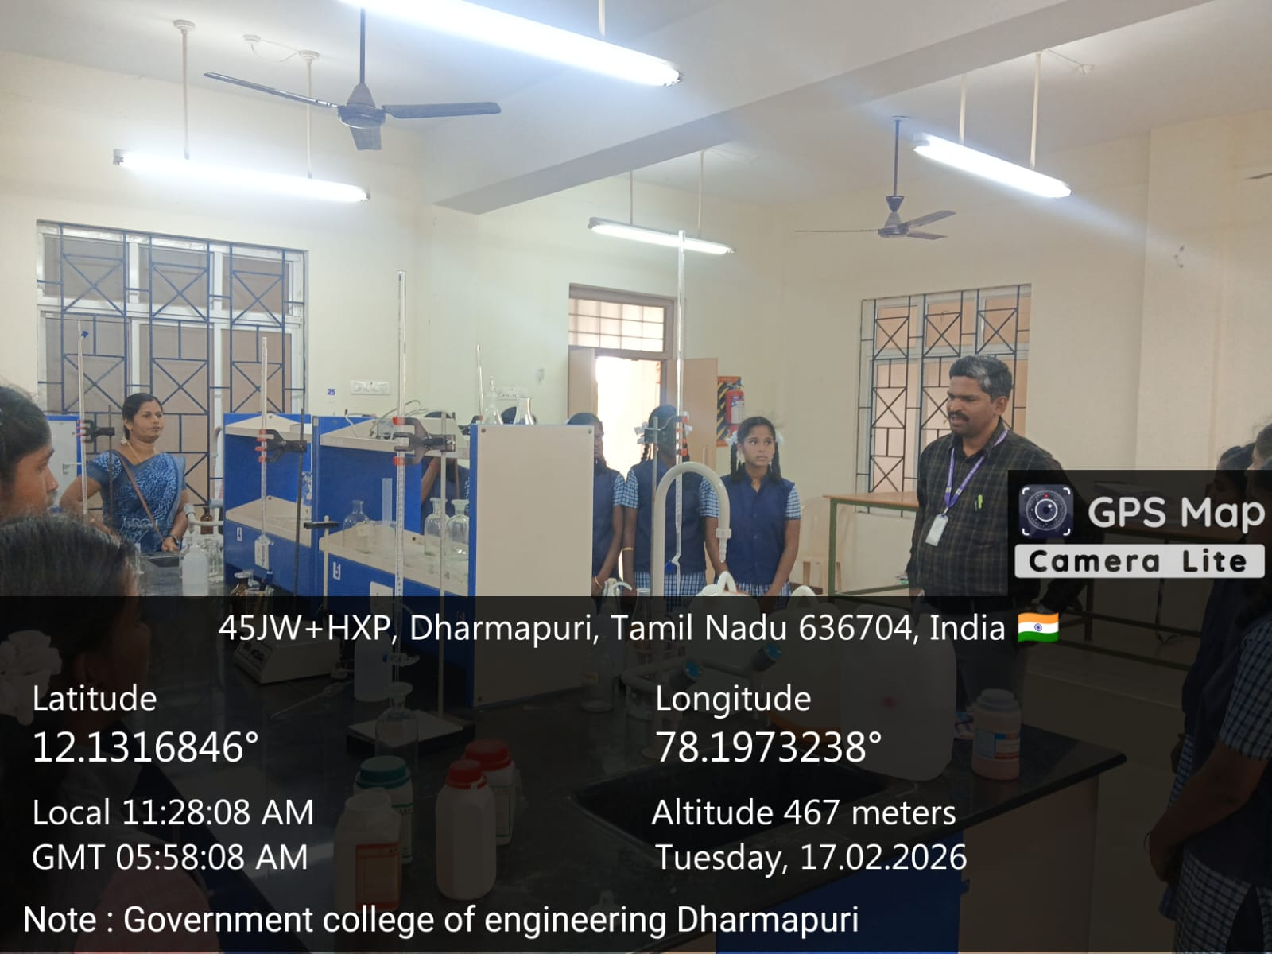 | 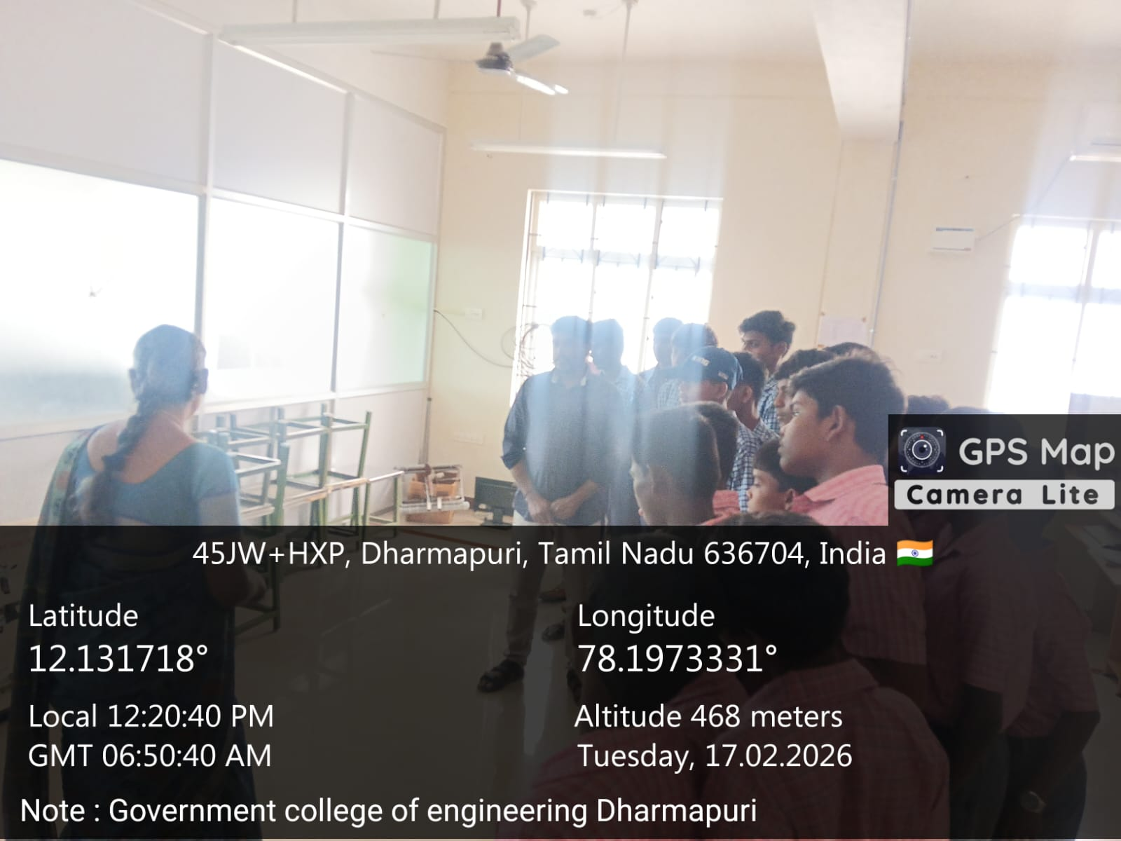
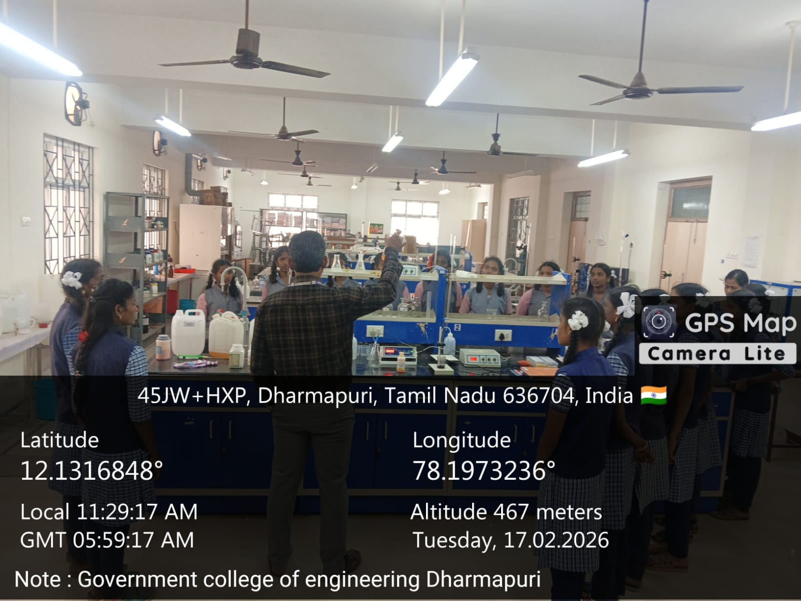

Thank You

